Welcoming you back to the joy of travel
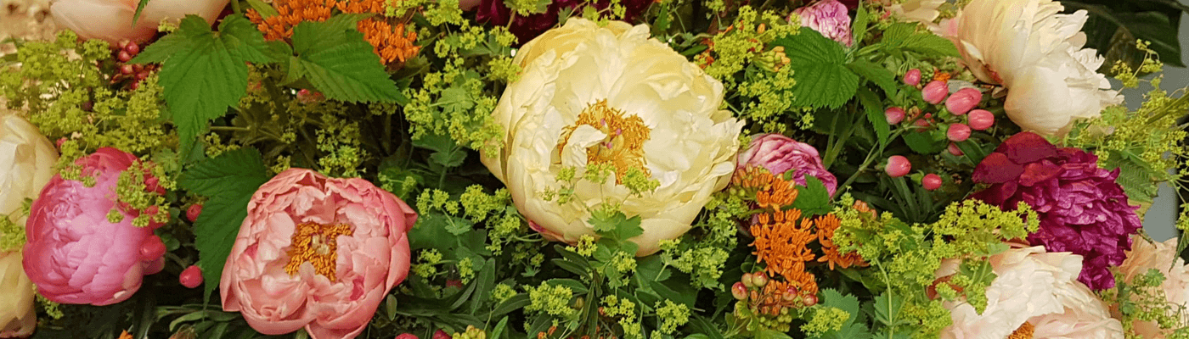

We are now eight months into 2020. I don’t know about you, but I miss the thrill of picking up my suitcase and setting off on my journey with the anticipation of energising new experiences ahead of me. The awe and wonder of taking in new scenery, discovering historic locations, tasting new foods and drinks and experiencing local life, trusty guidebook in hand and with local guides to educate and inform. I miss the luxury of being looked after too.
Looking back to March, our last tour returned from India just a couple of days before the Indian Government halted international flights. As events unfolded, my priority was to ensure customers booked on future tours were kept informed of the latest guidelines as Governments worldwide started to implement local restrictions, lockdowns and border closures. My team was busy updating customers and issuing refunds as required. I am proud to say that everyone who had booked to travel with us in 2020 has now either received a full refund or chosen to join the tour on new dates. And instead of charging for these transfers like many companies, we have given each of our customers a bonus travel voucher to use against future tours.
As we dealt with the cancelation of our 2020 tour programmes, it seemed to me that the best use of this time for the business would be to refresh our tour portfolio with new travel options and update our on-line presence and engagement. Importantly, I have also been reviewing our current terms of business with our insurance brokers and legal advisors to see how we can improve and manage our duty of care to you, our customers, going forward.

New Travel Horizons & Our Tour Favourites

Over the past months I have focused on a number of new and exciting destinations with the objective of creating, in collaboration with our local partners, responsible, immersive, experiential tours that offer a range of different opportunities to really get to know more about the places where you are spending your time.
We have found over many years of arranging tour programmes that you want to know more about the places you are staying in; that you want to spend time enriching your knowledge and expertise of favourite pastimes and also join in and experience new activities. We are also aware that, even when you travel together as friends or couples, your individual interests differ and you would like to have the opportunity of experiencing different activities whilst away together.
Our new tours provide all these opportunities and we have also refreshed familiar favourites, ensuring that these much-loved programmes continue to inspire.

Responsible Travel
This time has given us all the opportunity to reflect on our priorities, what is important to us and how we turn these objectives into our guiding steps for the future. Travel is a great educator and can influence as little or as much as an individual would like, offering positive experiences from the best pizza you have ever tasted to the wonder of seeing the Taj Mahal at first light.
My current focus is on Responsible Travel and ensuring our tours have a positive benefit on the destinations and communities we visit. Our new tours offer opportunities to meet local people, experience their culture and gain insights into how they are managing their local environments, whether that is managing and sustaining the vibrancy of coral reef fish life in St Lucia, creating productive forest gardens in Kerala or visiting some of the UK and Europe’s most innovative flower growers.
Responsible Travel will guide the future of our tour planning to ensure travelling with us will be a positive experience and a force for good at the destinations we will visit. Responsible also means sustainable and I am currently investigating how we can best off set the carbon emissions generated by our tours.
Your Welfare
Customer care is at the heart of what we do, and, in these challenging times, that is more important than ever. Be assured that we are here to look after you. I have personally been in touch with our hotel and coach company partners to ensure compliance with local COVID safe regulations, our Tour Managers will be COVID safe aware and will be following set guidelines to ensure your wellbeing while on tour. All the airlines who provide flights for our tours have COVID safe measures in place. We follow local adjustments to the regulations closely and will always ensure our supplier compliance.
We will, of course, provide information on our website as to the measures we are taking to ensure your wellbeing while you are on holiday. As the global situation can change quickly, we recommend that you review this information ahead of booking. Good travel insurance is essential. Many insurance providers do offer COVID cover and I strongly recommend that you check your travel insurance carefully ahead of booking your holiday.
Adaptability is now more important than ever and, as a small and highly experienced team, we can act swiftly to create holidays and short breaks that are both safe and enjoyable. And, it goes without saying that we will always honour our obligations; where refunds are due will continue to arrange these promptly.
What tour holidays can I book – and when?
Our first tours will be in Spring 2021 and include several short, experiential holidays in Europe covering a range of interests from quilting and textiles to gardens and flowers. For example, our holidays for flower lovers include tours to favourite festivals such as Keukenhof Gardens, Floralien in Ghent and, in September, the 25th anniversary of the fabulous Fleuramour. We also have an unmissable opportunity to experience Springtime in Ireland with in-coming NAFAS President Michael Bowyer. Looking ahead to 2022, we are working on a tour to Floriade in the Netherlands which promises to cast unique perspectives on the Green City of the future. Our floral holidays take you to less-visited city destinations and are enriched with unique experiences such as visits to flower growers, hands-on workshops and expert talks.

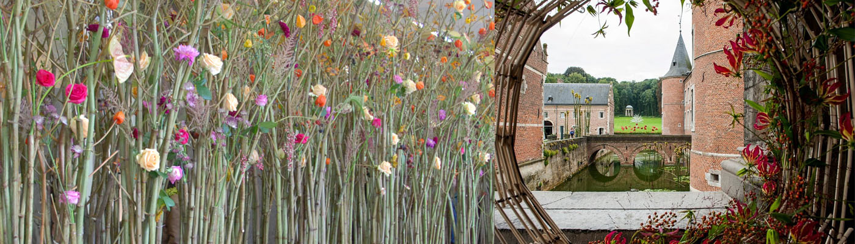

Travelling further afield, we will be offering meticulously planned holidays to the Caribbean, Asia and the Pacific where we will, of course, have a variety of travel options to visit New Zealand for WAFA 2023. Our long-haul programmes focus on the pleasures of Slow Travel. Rather than whistle-stop tours, these holidays allow you time to take it slow and make meaningful, lasting connections with the places you visit.
Signing up to Travel
If you are interested in any of these holidays, why not sign up? You can do so by visiting our website and filling in the form for the tour/s you are interested in, or simply email or phone to let us know. Registering early helps us to keep you informed and allows you to book as soon as the tour opens and get the best price!
Why not travel by coach?
I know that many of you enjoy travelling with your local clubs and special interest groups. We have been creating wonderfully diverse, tailor-made coach holidays for many years and would be delighted to work with you to create bespoke programmes to gardens, historic sites, museums and churches both here in the UK or in Europe. Coach travel has many benefits: it offers stress-free door-to-door travel with people you know, it’s ‘greener’ than flying and there are no luggage restrictions so you can bring back as many souvenirs as you like!
We are always delighted to work with your ideas or discuss suitable options, so please do get in touch.

We are ready to welcome you back to the joy of travel, with added reassurances that your safety is our top concern every step of the way.
Theresa McDermott, CEO ECT Travel

