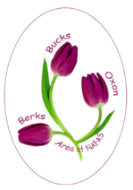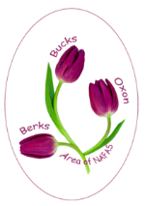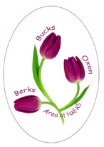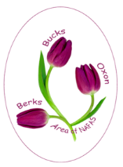

BB&O Area



BB&O Area



All inclusive tickets £20

This flier/form is also available under What’s On tab at bbandoflowers.org.uk or contact Jane Haas on 01187 984 1212





**All inclusive tickets £30**

For ticket applications see website under What’s On tab at bbandoflowers.org.uk or contact

Irene Manson on 0118 947 0737

Tickets on sale from March Council full payment required

**All inclusive tickets £30**

For ticket applications see website under What’s On tab at bbandoflowers.org.uk or contact

Irene Manson on 0118 947 0737

Tickets on sale from March Council full payment required

To Include

Afternoon Tea

&

A Welcome Drink

Dress Code: Diamonds and Flowers

To Include

Afternoon Tea

&

A Welcome Drink

Dress Code: Diamonds and Flowers

Departing 1.00pm – Returning 5.00pm

The Runnymede Boathouse, Windsor Rd,

Old Windsor, Berks

(Please DO NOT use post code on the Website)

Free Parking

Departing 1.00pm – Returning 5.00pm

The Runnymede Boathouse, Windsor Rd,

Old Windsor, Berks

(Please DO NOT use post code on the Website)

Free Parking

**Wednesday 15th July 2020**

**A Boat Trip on the Thames**

**to Celebrate**

**BB&O’s 60th Anniversary**

**Wednesday 15th July 2020**

**A Boat Trip on the Thames**

**to Celebrate**

**BB&O’s 60th Anniversary**