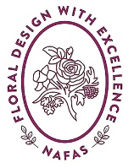
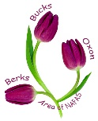
Berks Bucks & Oxon Area of NAFAS

Judges, Demonstrators, Speakers and Education Committee
Guidelines for Clubs Hosting an Area Workshop

The JDS&E have a brief to provide education for members of the Berks Bucks and Oxon Area (BB&O) of NAFAS. To achieve this, we are widening these opportunities by working together with Clubs to hold workshops in different locations.

These guidance notes provide information should your Club be interested is setting up a workshop.
- Workshops can be either full day, half day, or evenings or to suit and will be open to all NAFAS and non NAFAS members.
- Each workshop will be for a maximum of 20 participants (at the tutor’s discretion).
- Each participant will be required to provide their own materials as required for the workshop.
- The cost of each workshop will be agreed between all parties, all monies will go to the JDS&E. When all costs have been paid any profits made will go to the hosting Club.
- All workshops must be self-financing.

JDS&E will:
- The JDS&E Workshop Representative will liaise with the Club and support them in the requirements of a workshop, contact details can be found on the BB&O website bbandoflowers.org.uk or the Pink List.
- Pay the costs of the tutor, their materials, travel and the cost of hiring the venue.
- Ensure the workshop is advertised on the BB&O website and publicised across the BB&O area.

The Club will:
- Have a nominated representative to liaise with the JDS&E Workshop Representative.
- Find and book a suitable venue.
- Provide refreshments for the sessions any charges made at the discretion of the Club.
- Be responsible for the setting up and clearing of equipment used during the workshop.

