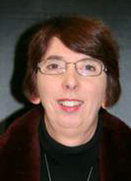
Rosemary McGowan – Profile - Nov 2016
Area Vice President, Area Judge, Treasurer and Vice Chairman of Judges, Demonstrators , Speakers and Education committee, member of the 2017 Area show committee and member of Club 2000.
I have been a flower club member for 30 years plus, since I joined an evening flower arranging class led by the late Penelope Everett in Aylesbury. I then did City and Guilds courses part 1 and 2 with Jane Rowton Lee which led me to train as and become an Area demonstrator. I demonstrated for a couple of years and later trained and qualified as an Area judge. In more recent times I successfully completed the NAFAS level 4 diploma course.
I have always enjoyed competing at Club, Area and National level, winning some awards also, over the years have been part of a team, several times, representing the Area at national level, winning awards, which include Gold at Malvern Spring show in 2015.
I was Area Treasurer for five challenging years and have served on two previous Area show committees. Last year I was Chair of the BB&O show committee at the Blenheim Garden show.
My hobby is likely to continue to be part of life.

