Berks Bucks and Oxon
Area of NAFAS

CREATE A WEBSITE
using

INDEX
Page No | Content
1 | Front Page
2 | Index
3 – 4 | How to get started
5 | Deciding what you want to include on your Website
6 – 7 | The Dashboard
8 | Making Changes to your Website  To add a Page
9 – 10 | Menus
11 – 12 | To delete a Page
13 – 14 | Templates
15 | To change your Site Title
16 | Header Image
17 | Fonts
18 | Colours and Backgrounds
19 – 21 | Editing a Page
22 – 24 | Widgets
25 – 26 | Contact Form
27 | Dashboard Enhancing Features  Permalinks
28 – 29 | Page Attributes
30 – 31 | Add an Image to your Page
32 – 33 | Adding a Website Link  Adding an Email Link
34 – 36 | Galleries and Sideshows
37 | Who to Contact

HOW TO GET STARTED
Access the Internet and enter https://wordpress.com
- The following screen will appear:
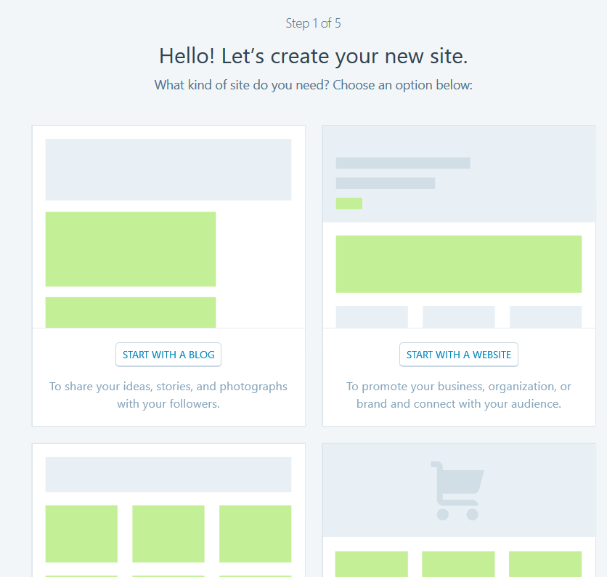
- Click on START WITH A WEBSITE
- Now choose a theme – Click on GATEWAY
Note: This can be changed later as there are many more to choose from
- You now need to give your site an address – Type in the name of your club with no spaces e.g. wantageflowerclub. .
Note: It is best to have the word ‘flower’ in the address if possible.
Note: For this manual I have called the site ‘Chartridge Flower Club’ and have selected the site name as chartridgeflowerclub.wordpress.com as this is free.

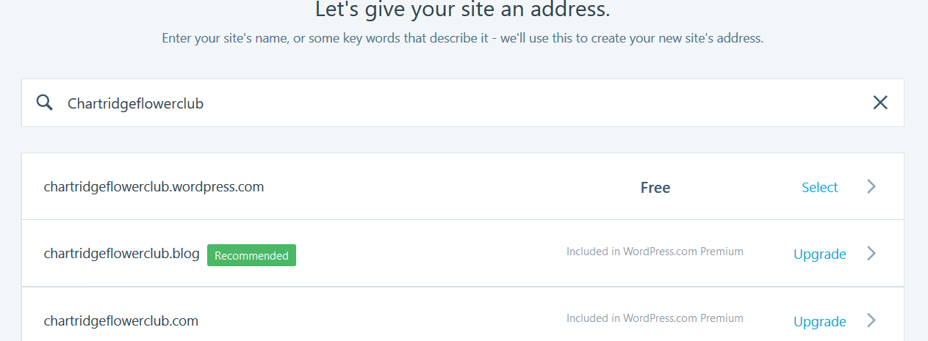
- Click on the site name you have selected and the following screen appears. Select the one that is FREE but clicking on the SELECT FREE button
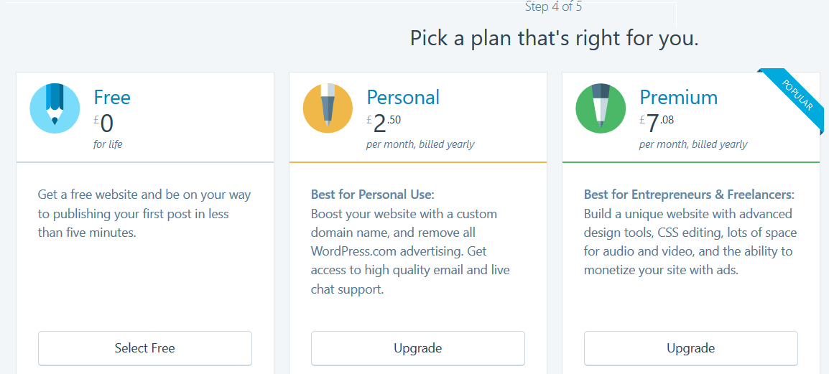
- The following screen appears where you need to enter your email address and choose a password.
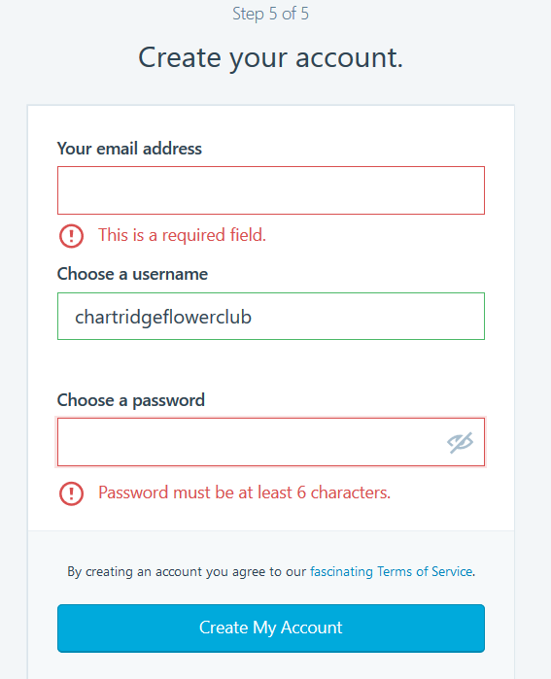
- Then click on CREATE MY ACCOUNT
- It will take a few seconds to create the account and the following screen will appear
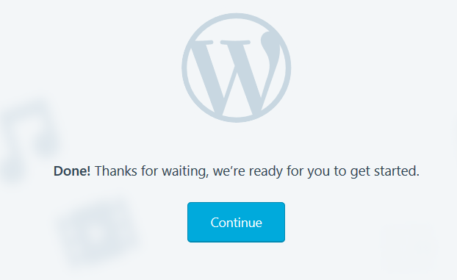

- You will be sent an email where you will need to confirm your email address. Do this NOW.
- Once you have confirmed your email address you will be taken to your site that you have created and this is where the fun begins!
DECIDING WHAT YOU WANT ON YOUR WEBSITE
It is important before you start editing the site to decide on the following:
- The Title of Website – the name of your club
- What pages you need. We recommend you have the following to start with:
  - Home
  - Club Programme
  - Committee or Who’s Who
  - Picture Gallery or Members Picture Gallery
  - Contact
Note: You can always add a page in at a later stage
- The Content of each page
Note: It is a good idea to have a look at other websites to see what they write and include
- The Contact Details you want to include on your site
- Have an image of your club logo if you have one
- Have access to Facebook and Twitter if you have these accounts already.

THE DASHBOARD
To access the Dashboard you will need to type in your website address e.g. https://chartridgeflowerclub.wordpress.com followed by /wp-admin

https://chartridgeflowerclub.wordpress.com/wp-admin

The Dashboard is where you set up your:
- Pages
- amend your pages
- add widgets and plugins (these will be explained later)
- change your theme
- set up menus
- and many more

Click on My Site at the top left hand side of your screen and you will see your website.

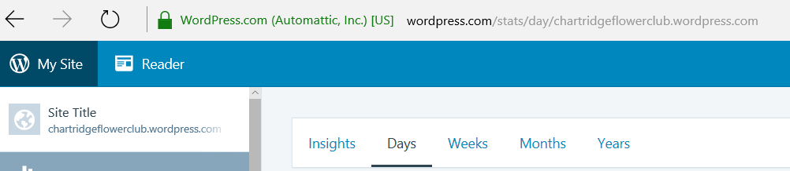

If you click on the website name, it will take you to screen that shows what your website looks like.

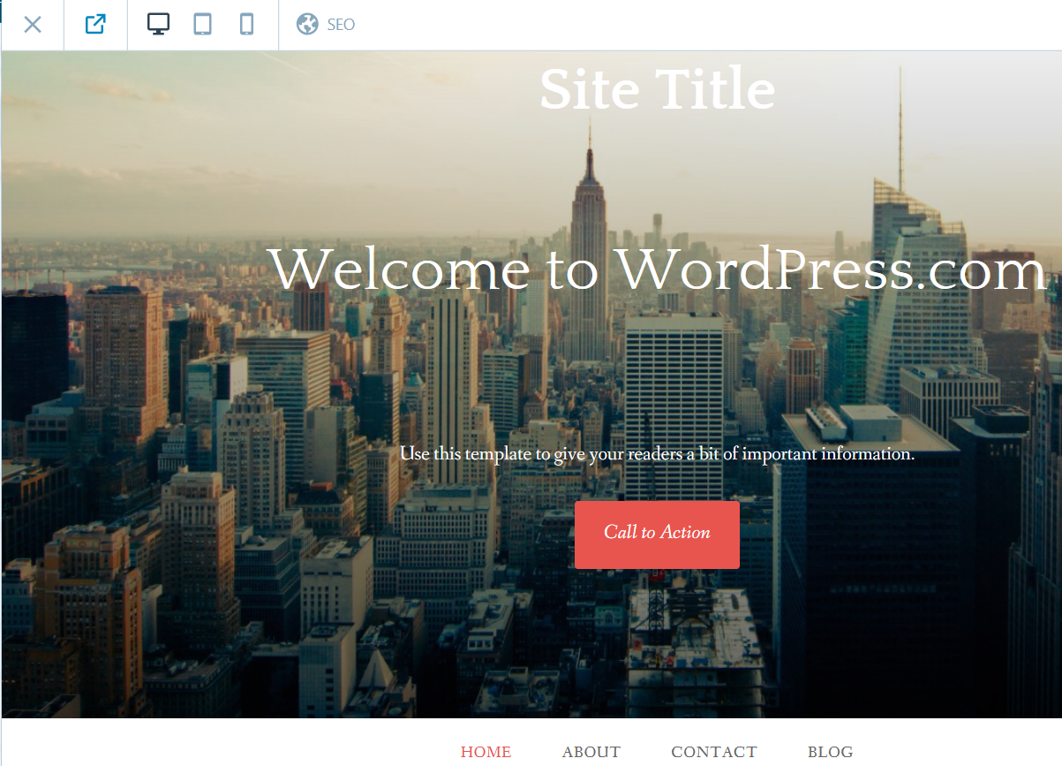

To close this down and return to the Dashboard click on the X in the top left hand side of the screen (shown above).

Now to make changes to your website

MAKING CHANGES TO YOUR WEBSITE

TO ADD A PAGE TO YOUR SITE

In Dashboard mode:
- Click on the ADD button alongside PAGES
- The following screen will appear:

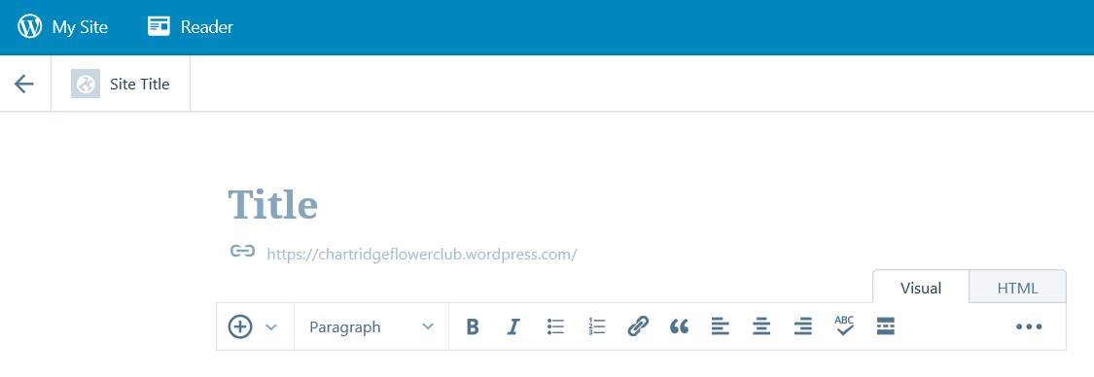
- Click where it says TITLE and type in the name of your page. For example CLUB PROGRAMME.
Note: It is best to do the name of the page in upper and lower case letters.
Note: At this stage don’t write anything in the text box as this can be done later.
- Click on PUBLISH at the top right hand corner of your screen. The following screen will appear to confirm your page has been saved/published.

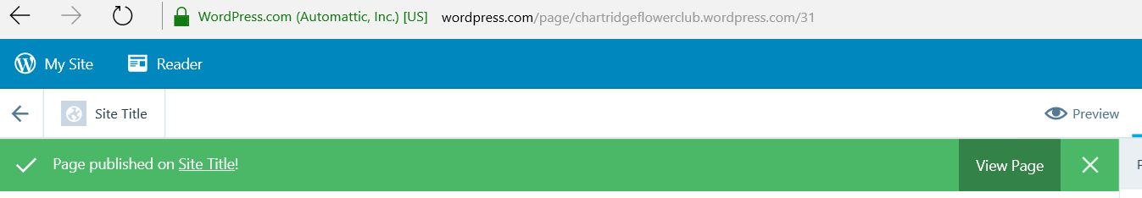
- Now click on MY SITE at the top left of your screen.
- Click on PAGES and you will see your saved page called Club Programme.
- To add another page, click on Add alongside Pages and give your page a new name e.g. Who’s Who or Committee etc. Remember to click on PUBLISH once you have typed in the name of the page.
- Click on MY SITE to return to the Dashboard.
- Now click on SITE TITLE in the top left hand corner of your screen to see what your site looks like. You will see that your pages you have not appeared so you need to return to the Dashboard (click on the X on the top left of the website page.

NOW WE NEED CREATE MENUS

MENUS

You need to be your Dashboard to create the Menus.

- On the left-hand side of your screen click on MENUS. The following screen will appear.

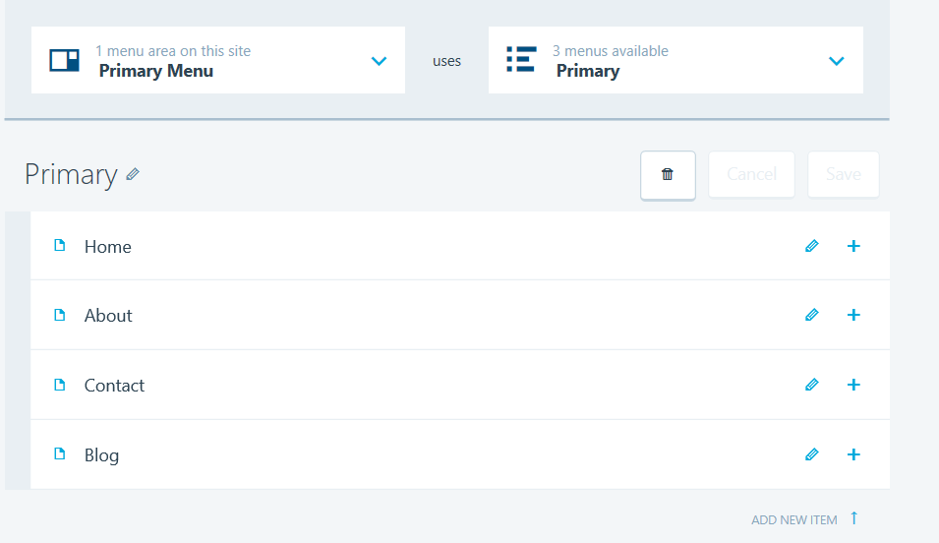
Note: This is where you will now be able to add the pages you have created to your website front page.
- You will see Home, About, Contact and Blog. To add your page called Club Programme, decide where you want to put it e.g. after About but before Contact.
- Click on the + sign alongside ABOUT as shown above and the following screen will appear:
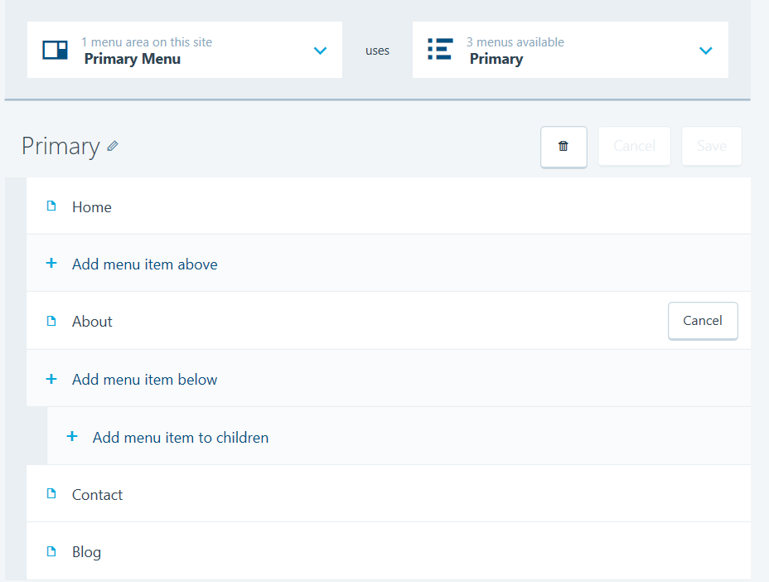
- Click on ADD MENU ITEM BELOW (not Add menu item to children). This will give you a list of the pages you can chose from to add. Click on CLUB PROGRAMME as shown below in the circle alongside it.
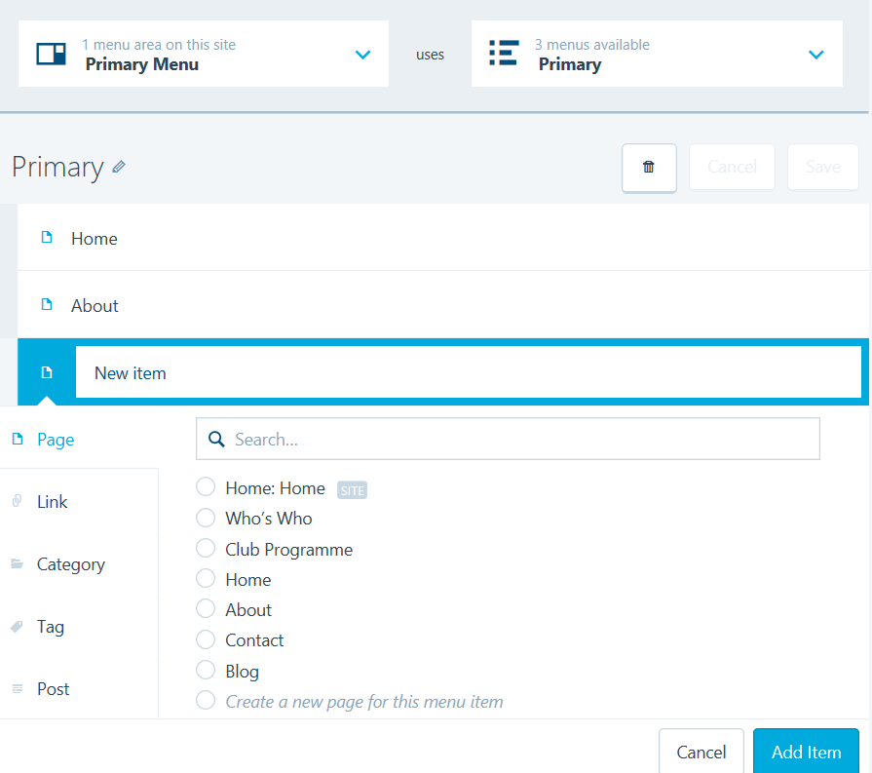
- Now click on ADD ITEM.
Note: You can only add one page at a time.
- You can now add your next page following steps 4 – 6 above.
- Once you have added all the pages you want, click on SAVE.

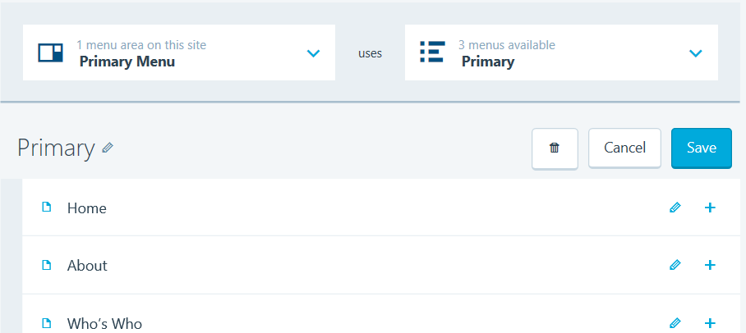
- Now click on SITE TITLE (top left of your screen) to check your website home page. You will now see that you have the pages you have created.

TO DELETE A PAGE

Go to your Dashboard and we are going to delete the BLOG page.
- Click on MENUS
- Click on the EDIT button alongside BLOG

- The following screen will appear. Make sure that BLOG has a black dot alongside it.
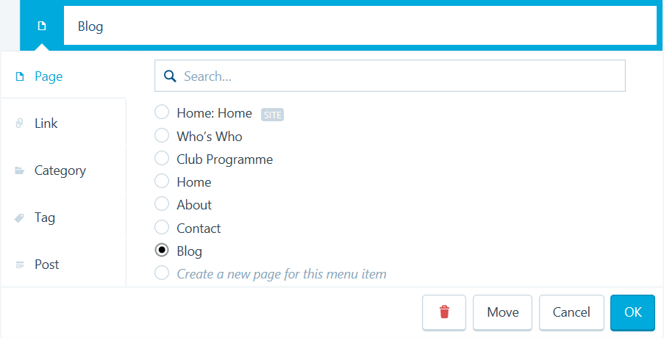
- Now click on the red bin – see above.
- The following screen will appear and you need to confirm that you want to delete the item. Click on DELETE ITEM.

- The following screen will appear without the page BLOG and you now need to click on SAVE.

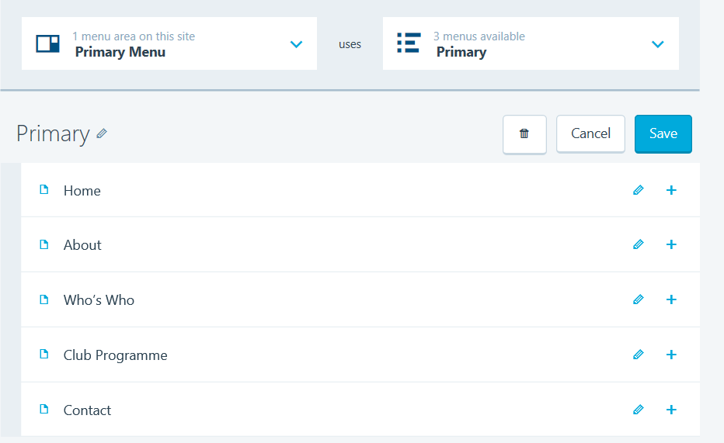
- Now check your site by going to SITE TITLE (top left of your screen) and it will confirm that you have deleted the page BLOG.

The next step is to look at different templates

TEMPLATES

There are lots of different templates to choose from, some are free and some you have to pay for. To keep costs down to a minimum it is good idea at this stage to look at free templates.

Go to your Dashboard and click on THEMES and the following screen will appear.

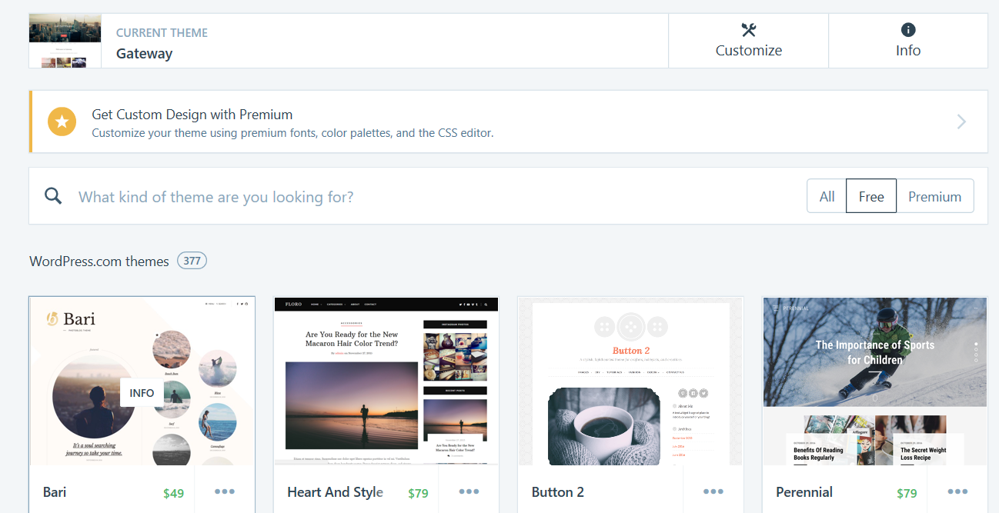

The current theme that you chose at the start was GATEWAY but you may decide that this is not the right one for your club so you need to:

- Click on the FREE button as shown above and this will give you all the free templates available to you for your website.
Note: TWENTY TEN is a good one as it will allow you to have a banner across the top of your site.
- For this manual we are going to use Twenty Ten so click on TWENTY TEN.
Note: You can find this easily by typing in the search box Twenty Ten. Click on TWENTY TEN.
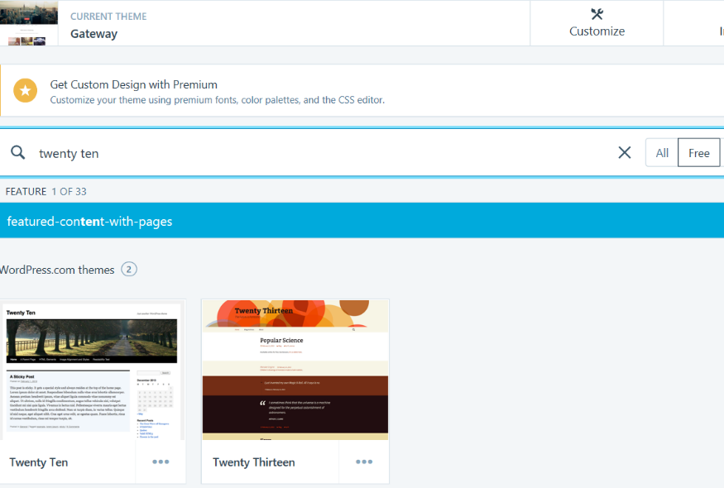
- The following screen will appear and now click on ACTIVATE THIS DESIGN FREE.
- The following box will appear and click on CUSTOMISE THIS DESIGN.

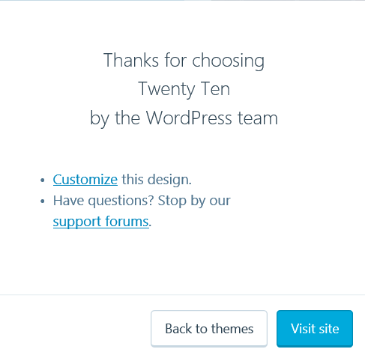

This is where you can customise your Site Title, Site Identity, Colours and Backgrounds, Fonts, Header Image, Menus, Widgets and Static Front Page.

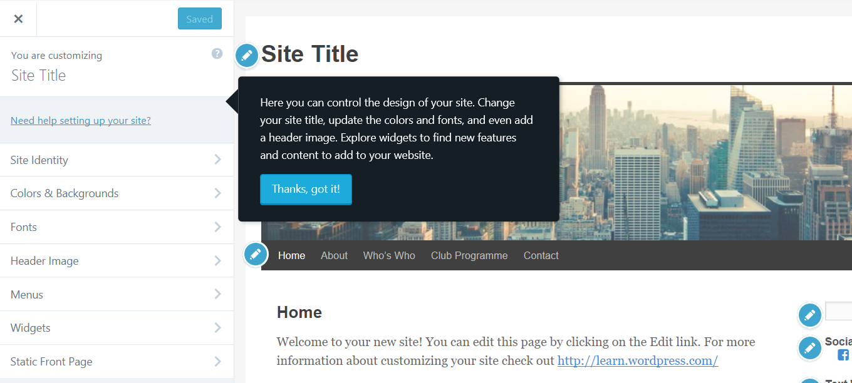

TO CHANGE YOUR SITE TITLE
To change your site title to your club name, click on SITE TITLE on the left hand column or alternatively click on the EDIT button – see below and the following screen will appear.
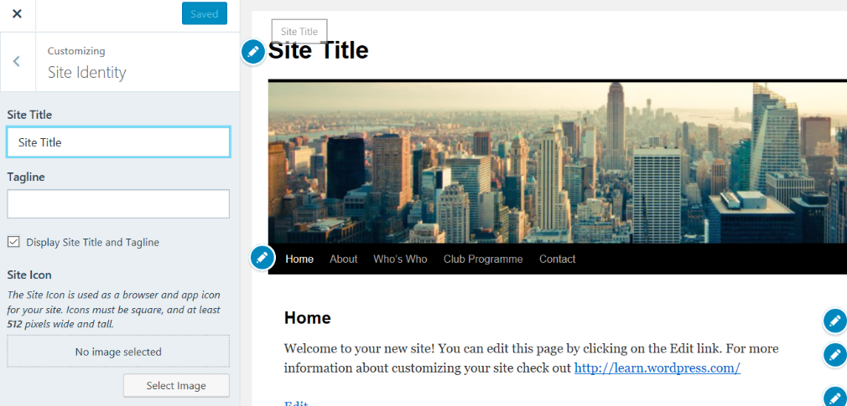
In the SITE TITLE box type in the name of the club e.g. Chartridge Flower Club.
TAGLINE
A Tagline is a further piece about your club e.g. Flower Arranging for Everyone in the Chartridge Area.
Note: The tagline should be short
SITE ICON
This particular theme does not allow a site icon.
- Now you need to click on SAVE & PUBLISH.
- Stay on this page

The next step is to change the HEADER IMAGE

HEADER IMAGE
On the Site Identity screen you need to click on the back arrow on the left hand column alongside CUSTOMISING SITE IDENTITY. This takes you back to the Customising Menu.

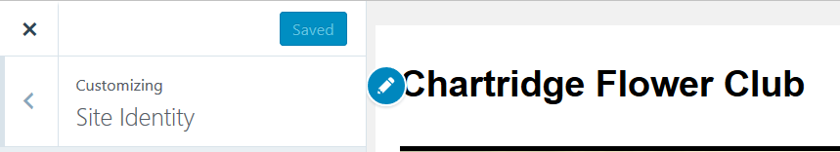

- Click on HEADER IMAGE
- To add a New Image, click on ADD NEW IMAGE
- Click on the UPLOAD FILES tab and the following screen will appear:
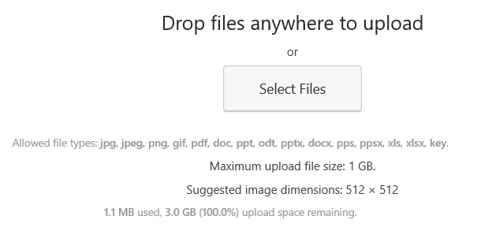
- Click on SELECT Files
- Find the image you have saved and click on the file name.
- A similar screen will appear with your image uploaded. It may take a few seconds to upload into the Media Library.
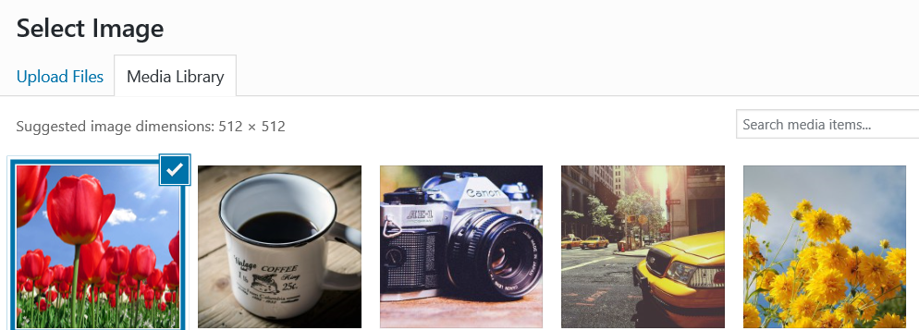
- Make sure your image is selected with a tick and click on SELECT at the bottom right of your screen.
- If you have a Crop Image screen click on CROP IMAGE at the bottom right of your screen.
Note: You can click on the image and move it around to get it to the image as the cropping may not be to your liking.
- Now click on SAVE & PUBLISH. It may take a few seconds.
FONTS

There are a variety of fonts to choose from and it is your own choice for this. You are able to change the Headings and Base Font.

- Click on the back arrow alongside CUSTOMISING HEADER IMAGE.
- Click on FONTS and the following screen will appear:
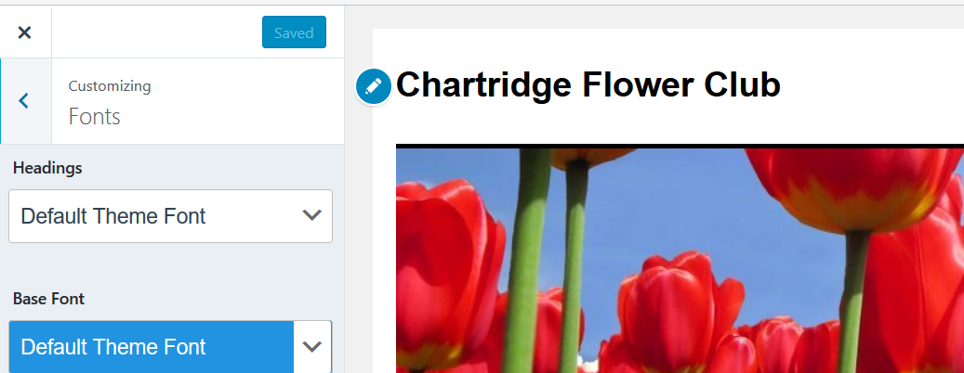
- To change the Headings Font click on DEFAULT THEME FONT under HEADINGS.
- Select a Font of your choice.
Note: If you click on a font you like it will automatically change on your screen e.g. Chartridge Flower Club as this is your heading.
- For the Heading that has been used on future images is ABRIL FATFACE
- To change the Base Font (this is the text throughout your website) click on DEFAULT THEME FONT under BASE FONT.
- For the Base Font, LIBRE BASKERVILLE has been used from now on.
- Now click on SAVE & PUBLISH.

COLOURS AND BACKGROUNDS

You can add a colours and backgrounds to your website. The default for this theme is white. If you wish to change the colours or backgrounds you will need to:

- Click on the back arrow alongside Customising Fonts to take you back.
- Click on COLORS & BACKGROUNDS. The following screen will appear:

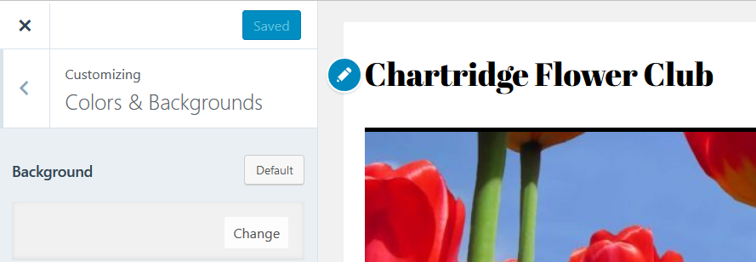

- Hover over the Background white box and you will see the word CHANGE. Click on it and it will give you a palette of colours to choose from.
- Click on the colour of your choice to see if you like it. If you like it then click on the DONE and then SAVE & PUBLISH.
Note: If you don’t like it then click on DEFAULT and then SAVE & PUBLISH and it will revert back to a white background.

At this stage, we will not amend the Menus, Widgets and Static Front Page.

Click on the X at the top left hand side of the screen just above You are customizing (Your Club Name) which will take you to your webpage for further editing.

The next step is now to now enter the text into your pages.

EDITING A PAGE

To edit a page you can click on MY SITE and then your Website e.g. Chartridge Flower Club – chartridgeflowerclub.wordpress.com.

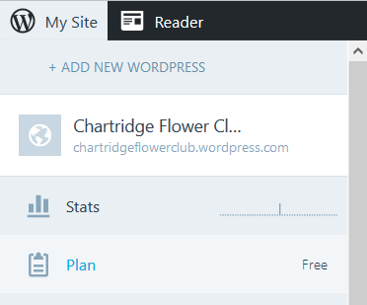

- A screen similar to the one below will appear:

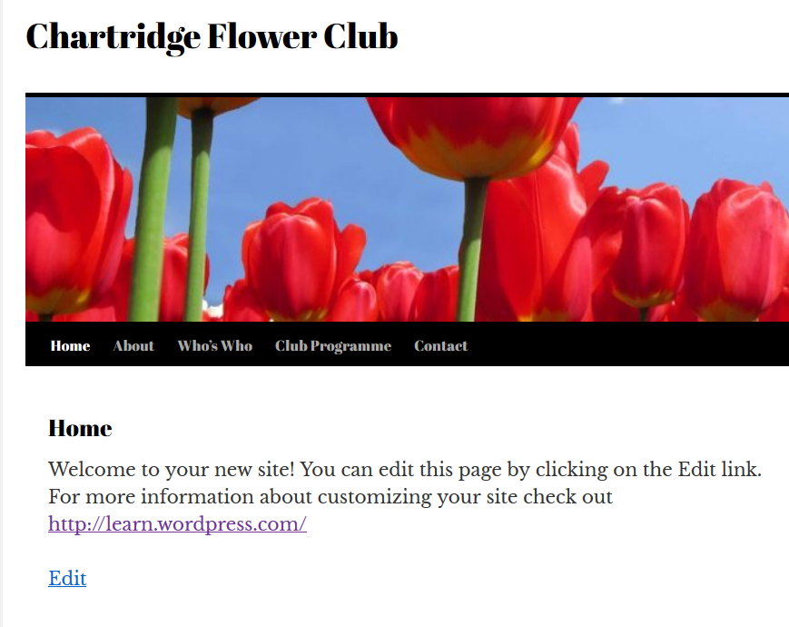
- Click on EDIT and this will take you to your page to edit.
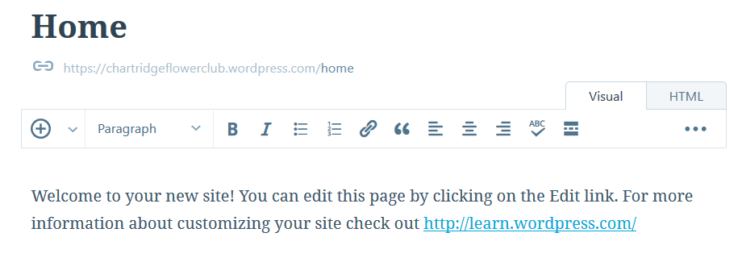
- Delete the text from Welcome to your new….. to check out http:learn.wordpress.com
- Now enter in your text
Note: It is a good idea to include the following on your Home Page:
  - Welcome e.g. Welcome to flower arranging in Chartridge.
  - Mention BBandO and NAFAS e.g. Chartridge is part of the Berkshire, Buckinghamshire and Oxfordshire (BBandO) Area of the National Association of Flower Arrangement Societies (NAFAS).
  - Explain what your club does e.g. demonstrations, workshops, outings, social events, Quizzes to raise money for charity etc.
  - Images (this will be explained later how to do this).
- Then click on UPDATE on the top right of your screen.
- A message on a green bar will confirm you have updated your website.
Note: you can view your page by clicking on VIEW PAGE or alternatively click on the name of your club.
- If you need to add or amend any text on the page, click on EDIT again.

Now click on the name of your club again in the top left hand of your screen, edit the next page e.g. Who’s Who using the same method.

Do this for all of your pages.

Who’s Who Page
You can include:
- Links to NAFAS
- Links to BBandO
- Committee Members
  - Name
  - Position
  - Email Address
  - Contact Telephone Number
Note:
Many people are wary of giving out too much information so you must get the persons permission to publish their name, email address and telephone number.

It is a good idea to set up a club email address. You can ask us to set up a club email address which will allow you to have the emails forwarded to several people. Contact media@bbandoflowers.org.uk.

Club Programme Page
You can include:
- Day
- Date
- Month
- Type of Event (e.g. Workshop, Demonstration, Social etc.)
- Presented by (e.g. Demonstators or Teachers Name)
- Title of the Demonstration

Contact Page
You can include:
- Who to contact for membership including a name, email address and telephone number
- Who to contact for information on the demonstrations / events etc.
- An Enquiry Form (this will be explained later in this manual)
- Google Map (This will be explained later in this manual)

Other Pages you could set up and include on your website are:
- Useful Links
- Photos
- Newsletters
- Other Demonstrations
- Garden and Flower Shows
- NAFAS
- BB&O (www.bbandoflowers.org.uk)

Now you need to enhance your website

WIDGETS

A WordPress Widget is a small block that performs a specific function. You can add these widgets in sidebar also known as widget-ready areas on your web page.

You need to be in the Dashboard to access your widgets that are already on your site.

- Click on CUSTOMIZE alongside THEMES on the left column on your screen.
- Click on WIDGETS
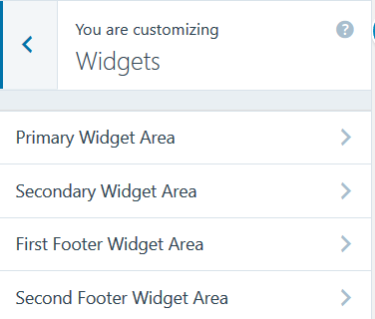

- Click on PRIMARY WIDGET AREA
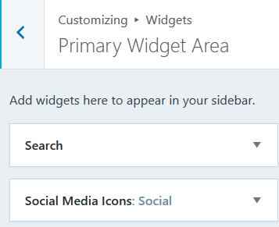
- Click on SOCIAL MEDIA ICONS
Here you can add accounts such as Facebook, Twitter, Flickr, Pinterest etc. that your club may have or you could link to the BBandO accounts.
- You can amend the TITLE to SOCIAL MEDIA if you like.
- If you have a Facebook Account add in the Facebook username. If not, then it would be a good idea to link to the BBandO Facebook account which is bbandoflowers
- If you have a Twitter Account then add in the Twitter username. If not, then add in the BBandO Twitter account which is bbandoflowers
- If you have an Instagram account then add the username in the box. If not remove the Hashtag (#).
- If you have a Pinterest Account then add in the address. If not, then enter in bbandoflowers
- Remove the Hastag (#) in the Linkedin box.
- Scroll down to the Flickr box and if you have a Flickr account add in the address. If not then use nafasbbo/albums
- Now click on SAVE & PUBLISH
- You can check they work by going back to the Dashboard
- Click on your Club Website
- Click on one of the Social icons e.g. Facebook and this should take you to your site.

TEXT WIDGET

Underneath your Social Icons on your Home Page is a Text Widget.

- You can edit this by clicking on the CLICK TO EDIT THIS WIDGET button
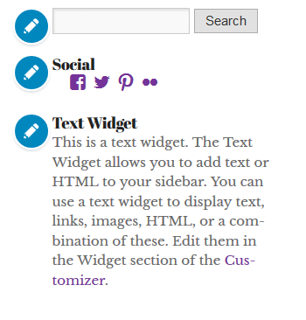
- A box will appear on the left hand side of your screen where you can edit your title and text
- This box could be used for instance to advertise your next Demonstration or Social Event etc.
- Click in the Title Box and delete Text Widget and amend to Next Demonstration
- In the Content Box remove the text and type in information about your demonstration
- Then click SAVE & PUBLISH.

If you do not want to have a Text Widget, then just delete all the text in all the boxes and it will not appear.
Note: The two Text Widgets at the bottom of the screen are under First Footer Widget Area and Second Footer Widget Area.

TO ADD A DIFFERENT WIDGET
- Go to the Dashboard
- Click on CUSTOMISE alongside THEMES
- Click on WIDGETS
- Decide where you want to put your widget. For this exercise we are going to put it in the First Footer Widget Area. Click on FIRST FOOTER WIDGET AREA
- Click on +ADD A WIDGET
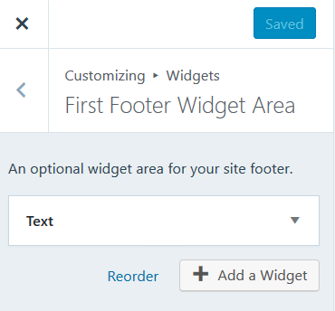
- A list of widgets will appear.

For this exercise we are going to add a Twitter Timeline and a Calendar.
- Click on TWITTER TIMELINE
- Change the Title to Follow BBandO on Twitter or if you have an account change it to Follow Us on Twitter
- In the Twitter Username box enter your account name or the BBandO Twitter username which is bbandoflowers
- Click SAVE & PUBLISH
- Check this has worked by going back to your website and scrolling down to the bottom of any page.

To add the Calendar Widget or one of your choice you need to go back to your Dashboard and then:
- Click on CUSTOMISE alongside THEMES
- Click on WIDGETS
- Click on SECOND FOOTER WIDGET AREA
- Click on + ADD A WIDGET
- Select your widget e.g. CALENDAR
- Leave the TITLE blank.
- Click SAVE & PUBLISH.

If you want to add further widgets then you can add two more using THIRD FOOTER WIDGET AREA and FOURTH FOOTER WIDGET AREA.
Note: Contact Info and Map Milestone are two widgets worth looking at.

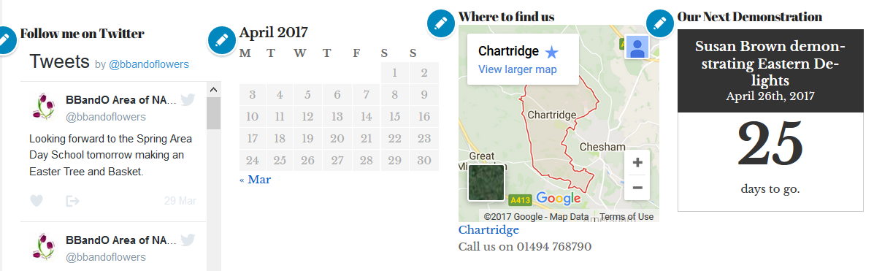

CONTACT FORM

For this theme, there is already a contact form on the Contact Page which may need amending.

- Click on PAGES on your Dashboard (not the Add Button)
- Click on the three dots on the right-hand side of your screen alongside CONTACT
- Select EDIT and the following screen will appear
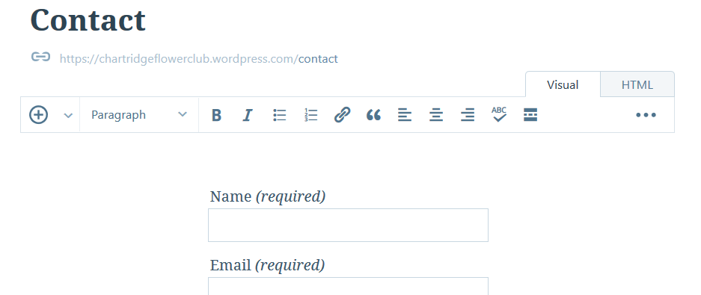
- Click on the drop down arrow alongside the + sign as shown above.
- Click on ADD CONTACT FORM – this will enable you to edit your form
- The website section is not required so click on the bin as shown below:
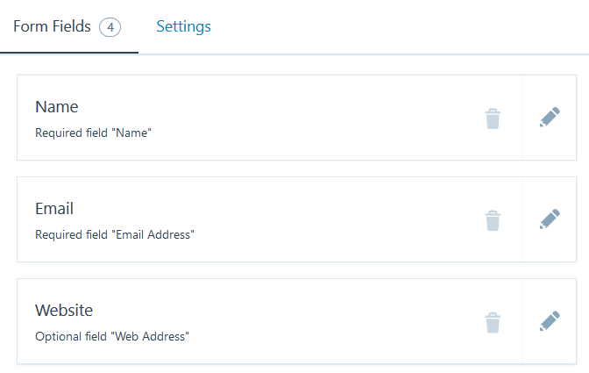
- This section will be deleted and you will be left with the following - Name, Email and Comment
- It would be useful to have a Telephone Number if you need to speak to someone so click on ADD NEW FIELD. The following screen appears:
- In the Text Box change TEXT to TELEPHONE NUMBER
- Leave the FIELD TYPE as TEXT
- Click on INSERT
- The following screen will appear

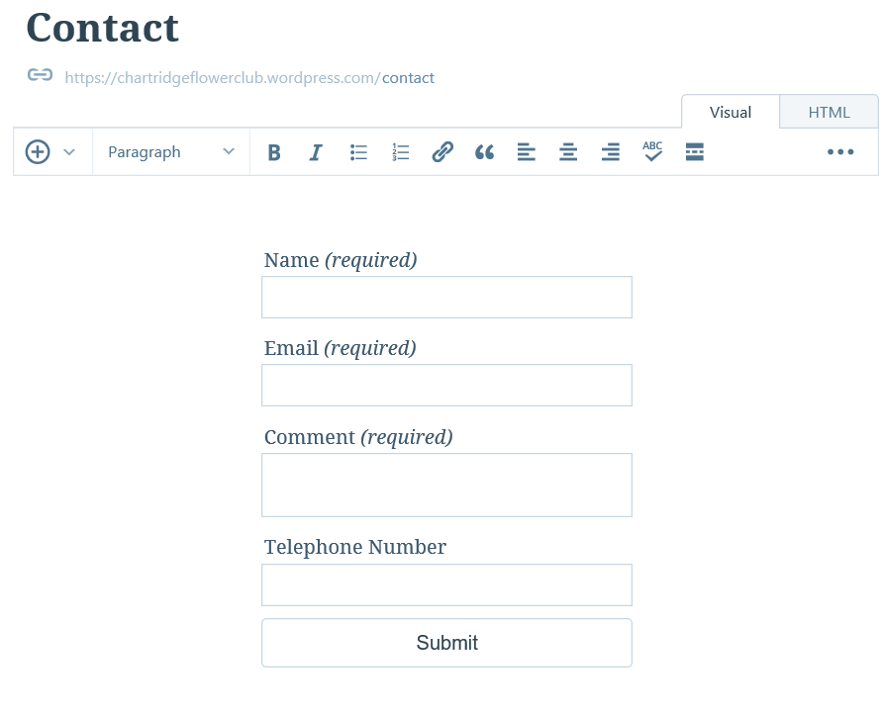
You will notice that the Telephone Number field is below the Comment box. This is not ideal and would be better below the Email box. To do this you will need to:

- Change the view from VISUAL to HTML by clicking on HTML
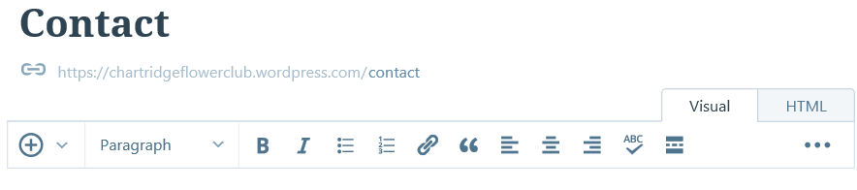
- Move the following [contact-field label="Telephone Number" type="text" /] to between type="email" required="1" /] and [contact-field label="Website"
- Once you have done this click on Visual and if it has been completed correctly then the Telephone Number Field will be just below the Email Field.
- If you are happy, then click UPDATE.

DASHBOARD – ENHANCED FEATURES

To access the Dashboard which will give you more scope to do different things on the website you can access by typing your website address e.g. https://chartridgeflowerclub/ followed by wp-admin

Therefore, you would type https://chartridgeflowerclub/wp-admin

Permalinks
These are the link that you will find appear your service provider search box. For instance https://chartridgeflowerclub.wordpress.com/club-programme

To amend a Permalink you need to be in the Dashboard using the website address followed by wp-admin and click on PAGES. The following page will appear with all of the pages you have set up.

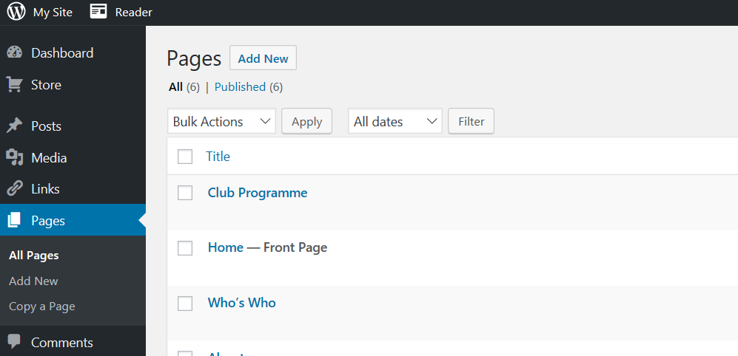

- Select the page you wish to change the Permalink e.g. Club Programme
- Click on EDIT alongside your Permalink – see below
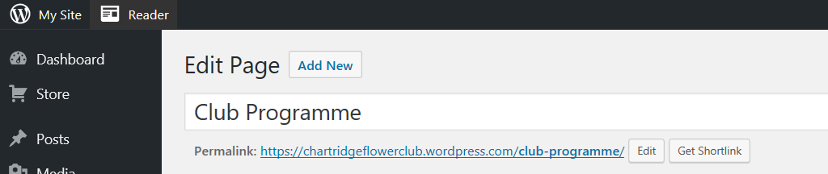
- Change the Permalink from club-programme to clubprogramme
- Click on OK
- Click on UPDATE on the right-hand side of your screen.
- Click on PAGES on the left-hand side
- Hover over Club Programme with your mouse and click VIEW
- You will notice that the name in the Search box at the top will have something similar to the following:
https://chartridgeflowerclub.wordpress.com/clubprogramme/

Note: You can change any of your pages permalinks if you think appropriate.

PAGE ATTRIBUTES

Page Attributes allows you to change the way your page looks and where the page sits. For instance if you would like to have a page sitting.
Parent — You can arrange your pages in hierarchies. For example, you could have a “Who’s Who” page that has “Committee”, “NAFAS” and “BBandO” pages under it. There are no limits to how many levels you can nest pages.
Template — Some themes have custom templates you can use for certain pages that might have additional features or custom layouts. If so, you’ll see them in this dropdown menu.
Order — Pages are usually ordered alphabetically, but you can choose your own order by entering a number (1 for first, etc.) in this field.
Note: Some Themes do not support sub-menus and Theme Twenty Ten unfortunately is one of them. However, you could if you want change your theme to say Baskerville which will allow sub-menus or find another theme that you like.
Note: For Flower Clubs setting up a new website, hierarchies are necessarily needed and if you want to have a page you can show it on your front page.
To change these you will need to be in the Dashboard (your website address followed by /wp-admin.
Arranging your Pages with hierarchies
- Click on Pages and select ADD NEW
- Give your page a name called NAFAS
- At this stage do not write any text in unless you know what you want to write.
- On the right-hand side of the screen click on the drop down menu under PARENT where is says (no parent).
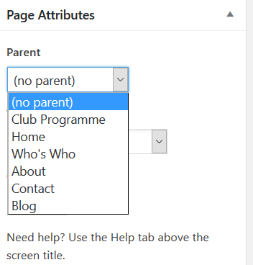
- A drop-down menu will appear as shown above. Click on WHO’S WHO
- Click on PUBLISH.

Default Templates

Under Page Attributes you can change the way your page looks. Different themes allow different ways.

- Go to PAGES
- Click on the PAGE you wish to change the layout on e.g. NAFAS
- Under Page Attributes click on the drop-down arrow under TEMPLATE
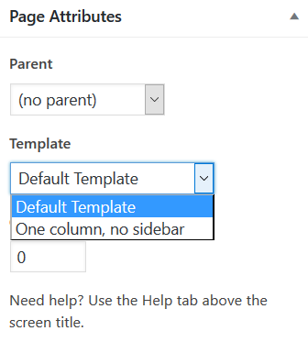
- Twenty Ten only has two templates, the Default Template and the One Column, no sidebar. Click on ONE COLUMN, NO SIDEBAR
- Click on UPDATE
- To check out what you page looks like go to your website and click on NAFAS. You will see that the sidebar that had the Social Media Icons and Next Demonstration has disappeared.
Note: If you want to revert back to the original layout, follow steps 1 – 3 above and then click on DEFAULT TEMPLATE. Remember to click on UPDATE.

ADD AN IMAGE TO YOUR PAGE

It is more pleasing to the eye if images are added to your page. You can do this by using the MEDIA and PAGES button on your DASHBOARD.

MEDIA
- Click on MEDIA and the Media Library will appear. Your screen will look similar to the one below.
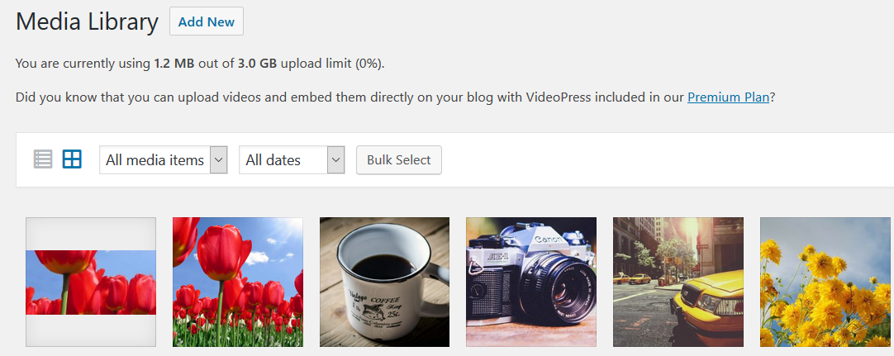

To add a new image to the Media Library

- Click on ADD NEW
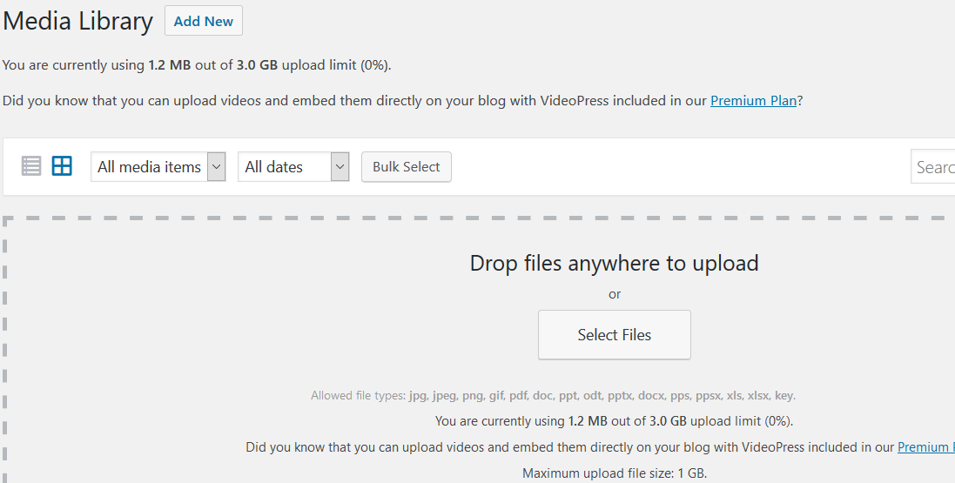
- Click on SELECT FILES
- Find the image that you want to add to your Media Library from your computer. For this exercise, I have uploaded a map of the NAFAS areas and a Facebook Icon.
Note: If you have other images such as your Club Logo or the BBandO Logo then upload them now. Otherwise you can upload images at any time.

Note: You are unable to upload Videos on the Free Plan. To do this you would need to be on the Premium Plan.

To add an image to your page

- Make sure you are in your Dashboard.
- Click on PAGES
- Click on the Page you wish to add your image e.g. NAFAS
- Click on ADD MEDIA
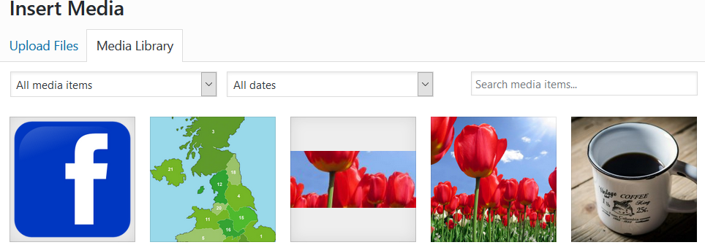
- Click on the image you wish to add to your page e.g. the map.
- Click on INSERT INTO PAGE at the bottom right of your screen.
- You can click on the Map and select either left, centre or right align.
- Remember once you have the image where you want it, click on UPDATE.
- Note: You can click on VIEW PAGE at the top of your screen under EDIT PAGE to see what your page looks like. If you want to amend your page, then go back to your Dashboard and find your page.

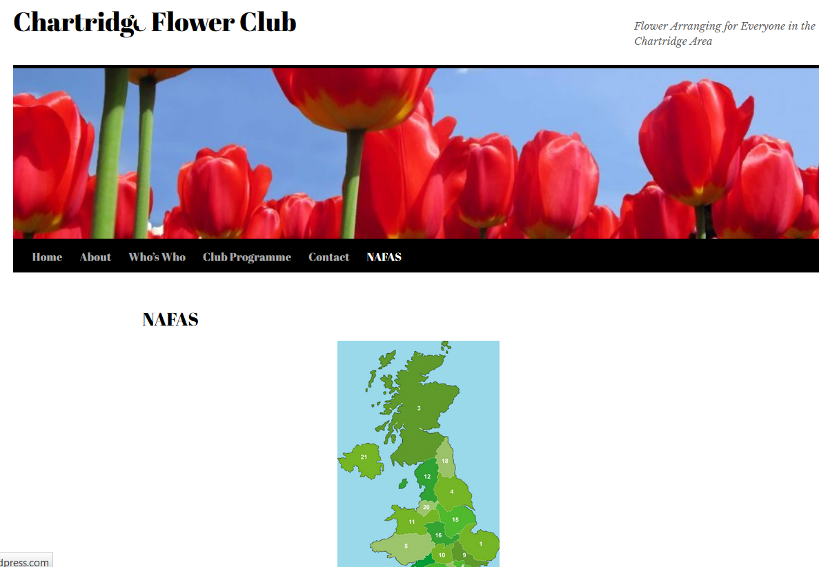

LINKS

Links such as website addresses or email addresses can be added to any text.

For instance if you have a name of a contact you can hide behind the name their email address or the club email address.

Another example is that if you refer to NAFAS you can have their website address hidden behind the name so that a visitor to your website could click on NAFAS and it would take them straight to the NAFAS website.

ADDING A WEBSITE LINK

- Click on the page you wish to add your link. For this exercise the link is being added to the NAFAS page.
- Highlight the word or words that you wish to add the link to e.g. NAFAS
- On the toolbar there is a button called Insert/Edit Link(Ctrl+K). Click on this button – see below.

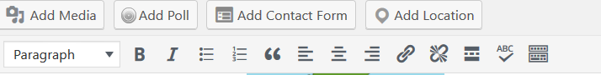
- A box will appear where you can add the URL. Enter in the website address e.g. http://www.nafas.org.uk/
- Click on the APPLY button – see below
- You will notice that NAFAS will now be in a different colour and underlined.
- Click on UPDATE.
Note: To check the link is working, click on VIEW PAGE and then the link you have set up. You should be taken straight to the NAFAS website. If your link is not working, check the URL that you have entered.

ADDING AN EMAIL ADDRESS

This is very similar to adding a URL. For this exercise you will add an email address to a name on the Contact Page.

- Click on the page you wish to add your link e.g. Contact Page.
- Highlight the name that you wish to add the link to e.g. Jennifer Button
- On the toolbar there is a button called Insert/Edit Link(Ctrl+K). Click on this button – see below.

- A box will appear where you can add the URL. Enter MAILTO: followed by the email address. For example enter in the box mailto:jenniferbutton@btinternet.com
- Click on the APPLY button – see below
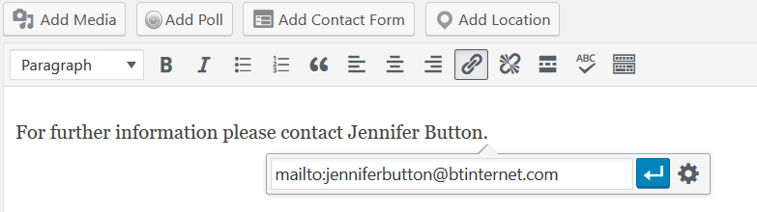
- Click on UPDATE
- Check the link is working by going to VIEW PAGE. You will see that the name you have added the email address to is in a different colour and underlined.

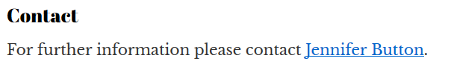
- Click on the name and this will take you to your email account with a new email addressed to this person.

GALLERIES AND SLIDESHOWS

For this exercise, you will need to create a page called PHOTOS

- Open the page called Photos for editing.
Note: If it is a new page, make sure you save it at least once before trying to insert a gallery or slideshow.
- Click the Insert Content button and select the Add Media button.

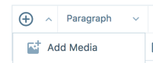

- You’ll now see the images in your Media Library. You can add new images from your computer by clicking on Add New, navigating to the images on your hard drive, selecting them, and click OPEN.
- Click on Create Gallery
- Select the images you wish to add to your Gallery by clicking on them.
Note: If you click on one by mistake, click on it again and it will de-select.
- Click on CREATE A NEW GALLERY at the bottom right of your screen. This will take you to EDIT GALLERY.
- If you want to change the order of the images you can click and drag the one you want to move to the correct place.
- If you want to add a caption to the image, click in the box under the image where it says CAPTION THIS IMAGE and type in the text.
- If you want more than three images across, click on the drop down arrow alongside COLUMNS under GALLERY SETTINGS and change to the number you would like e.g. 5.
- Click on INSERT GALLERY
- Click on UPDATE and you will have saved your Photos Page.
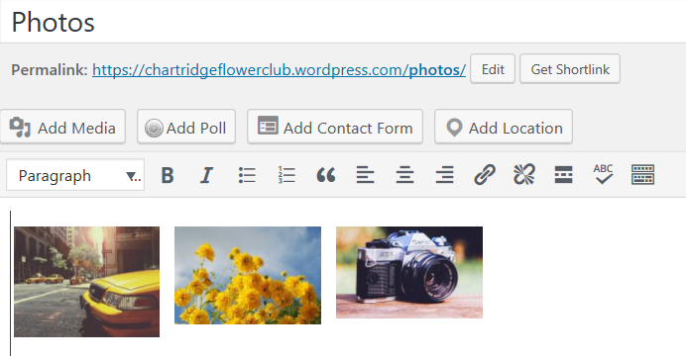
- If you wish to edit your Gallery, click on one of the photos and the following box will appear with a edit button
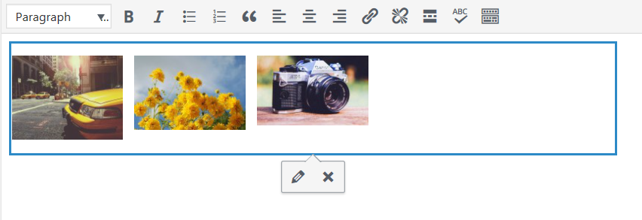
- Click on EDIT and you will be taken back to the EDIT GALLERY where you can add, delete photos or change the number of columns.

TO ADD TEXT TO YOUR PAGE WITH A GALLERY

It would be best to include some text above your gallery explaining what your gallery is about. Ideally this is best to be done before the gallery is inserted. However, if you follow these instructions you can add text above the gallery you have just added.

- Go to your Page where you have added the gallery. In this instance it is PHOTOS.
- Change the view from VISUAL to TEXT.
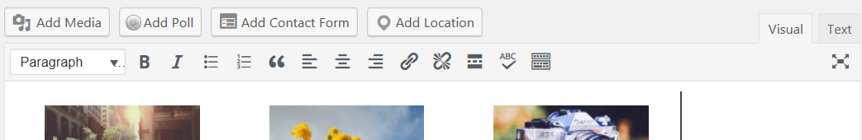

- You will see something similar to this on the screen - [gallery ids="28,27,29"]. This is your Gallery you have just set up with the images.
- Click at the start of the line and press ENTER.
- Click your mouse just above the text and then type in what your Gallery is about. For instance you could type: These are photos from the Demonstration by Cath Derby on April 4th 2017.
- Press ENTER – this will add a line space between your text and the Gallery.
- Click on UPDATE.
- Click on VIEW PAGE to see what your page looks like.
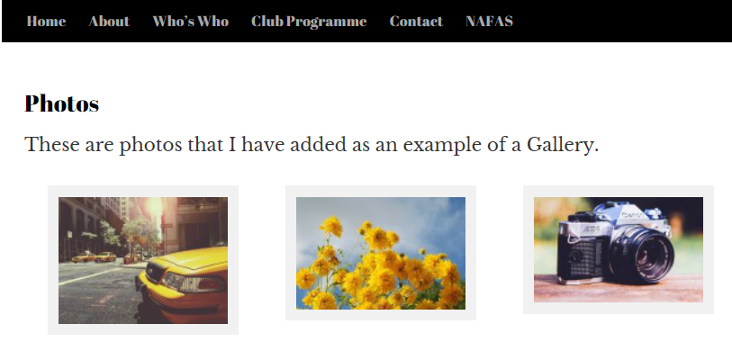
- If you do need to amend your page, click on EDIT at the bottom left of your screen and you can then change your page layout and/or Gallery.

WHO TO CONTACT

This manual is only a guide and a start to setting up a website for your club.

Support is at hand so if you have any queries about this manual and/or setting up your website please contact:

Anne Hyde
media@bbandoflowers.org.uk
01494 786770

