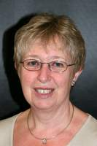Shirley Sexton – Profile - June 2016
I took up flower arranging in my early 50s when I wanted do something completely different after taking voluntary redundancy from my IT job. I started as a complete novice and over the next few years completed all 4 levels of the NAFAS course. Although I have done a small amount of teaching and demonstrating at my club I am not interested in specialising in these fields. My main passion is competition work – taking a theme and coming up with good design. I have won awards at local, area and national levels, including RHS Chelsea and Harrogate Flower Shows. I became an area judge in 2010.

