How to set up a Pinterest Account for your Flower Club
- Access the Internet and enter the web address - https://business.pinterest.com/en/set-your-business-account
- Click on JOIN AS A BUSINESS
- Enter your email address, password, Business Name (Club Name), Website address if you have one and under Business Type click on either OTHER
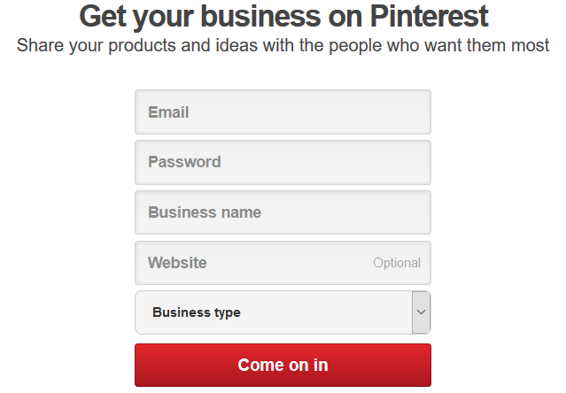

- Click on COME ON IN
- The following screen will appear:
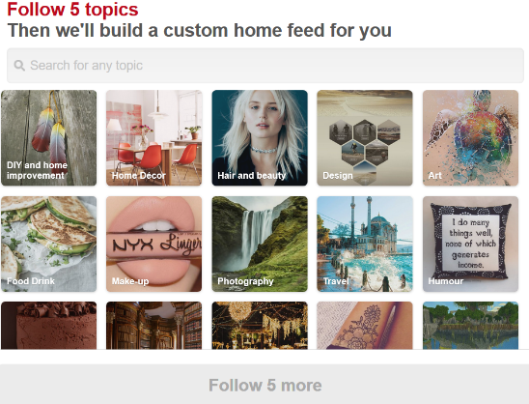

- Where it says SEARCH FOR ANY TOPIC type in the box FLORAL ARRANGEMENTS. The following screen will appear:
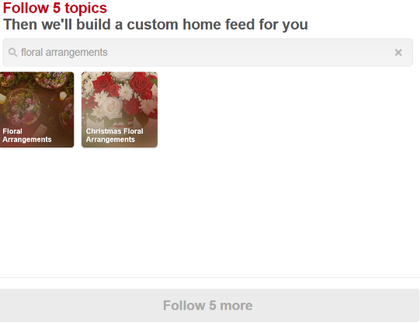

- You need to click on the image with FLORAL ARRANGEMENTS and CHRISTMAS FLORAL ARRANGEMENTS. Your page will look similar to the image below:
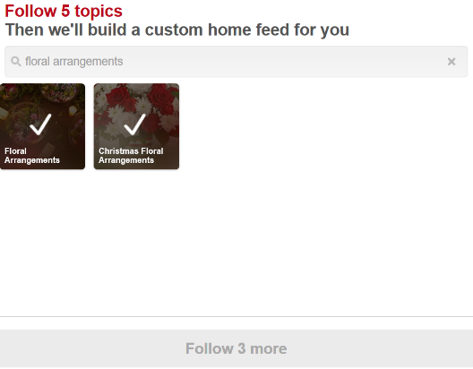

- Go back to the box where you typed in FLORAL ARRANGEMENTS and type in WEDDING FLOWERS and click on the image.
- Then go back to the box where you typed in Wedding Flowers and type in FLOWER ARRANGEMENT. Select MODERN FLOWER ARRANGEMENTS and SILK FLOWER ARRANGEMENTS.
- You will now have selected five different boards. DONE will appear (red bar at the bottom of the screen).
- Click on DONE.
- A box will appear with a heading GET THE PINTEREST BROWSER BUTTON. Click on GET IT NOW and follow the onscreen instructions.
- Your page will be set up for you.
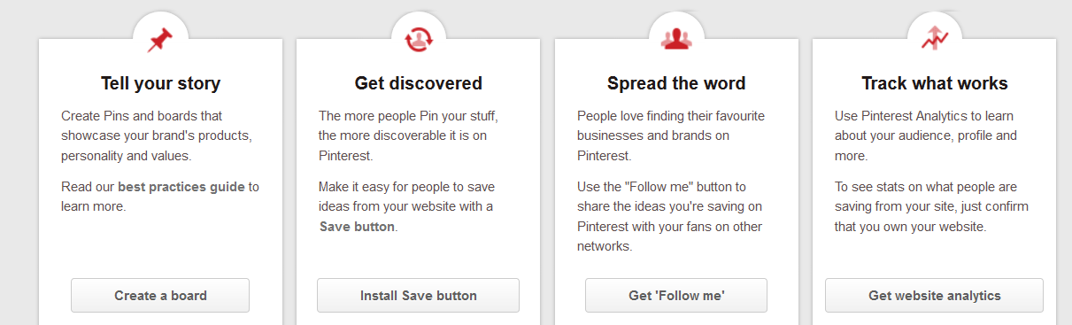
- You now have four different options:

TELL YOUR STORY
A Board is where you can showcase your own flower arrangements or add other arrangements to your board. To create a board you need to:

- Click on CREATE A BOARD
- Decide what the name of your board is going to be e.g. Ikebana
- In the Description box you can explain what you board is about.
- CATEGORY – You can either click on HOBBIES AND CRAFTS or OTHER from the drop down menu.
- SECRET – You want everyone to see it so leave it as NO.
- COLLABORATORS – leave blank
- Click on CREATE
- Your page should look similar to this:

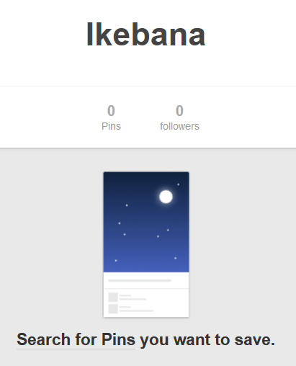

- Click on SEARCH FOR PINS you want to save
- In the Search Box type in FLORAL ARRANGEMENTS IKEBANA. A page similar to the one below will appear:
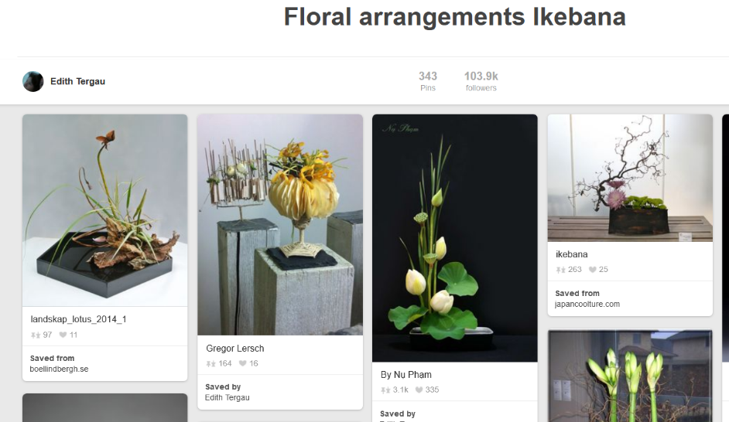

- Move you mouse onto one of the images that you wish to include on your board and a Save button will appear.

- Click on SAVE. The image will now be moved to your IKEBANA board and the following screen will appear:
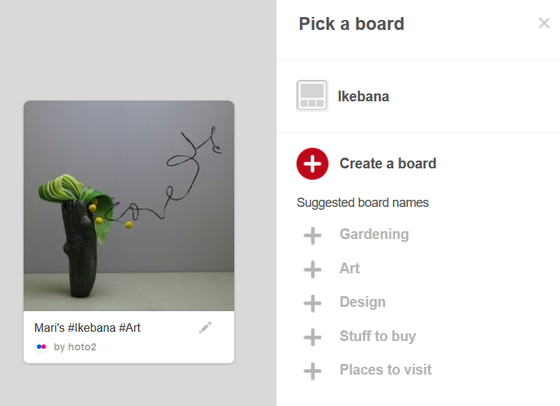

- To add the image to your board you will need to move your mouse to IKEBANA and then click the SAVE button.
TO ACCESS YOUR PINTEREST PAGE / CHANGE YOUR PROFILE
In the top right hand corner of your screen there is a PIN
Move your mouse onto the screen and then click on MY PROFILE. Here you can EDIT PROFILE and you will see all of your boards. The image you have just saved should be showing on the IKEBANA Board.
To add another board, click on CREATE A BOARD and set up another board e.g. MEMBERS ARRANGEMENTS, CLUB OUTINGS, DEMONSTATIONS, ROSE ARRANGEMENTS, YELLOW ARRANGEMENTS, GERBERA ARRANGEMENTS, MINATURE ARRANGEMENTS etc.
You can add as many images as you like to a board.
If you would like ideas for boards you can access LEY HILL FLOWER CLUB Pinterest Account by going to their website:
http://leyhillflowerclub.myfreesites.net and click on the Pinterest log at the top of the screen. Please note that you must have a Pinterest Account to access other Pinterest Sites.
EDIT PROFILE
Here you can add or change any information.
To add a picture click on CHANGE PICTURE. Find the picture you want and this will appear on your front page once you have saved it.
ABOUT YOU – Here you can add more information about your club. For example, where you meet, what you do etc.
By adding this information, you will get something like this on your front screen:

TRY PINTEREST ADS
If you get the following box appear on your screen, click NO,THANKS.
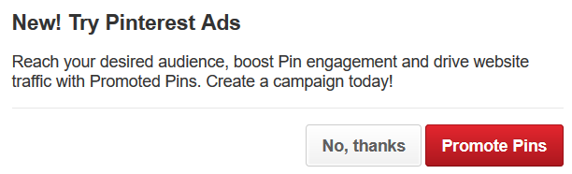

HELP
There is always HELP at hand. You can browse help topics by going to https://help.pinterest.com/en?source=gear_menu_web

Alternatively contact Anne Hyde – 01494 786770 or 07703 184268 or email mailto:media@bbandoflowers.org.uk

IMPORTANT
For Club Members wanting to access Pinterest
- Access the Pinterest site but do not click on Continue – just scroll down instead and they will find the boards you have created.

