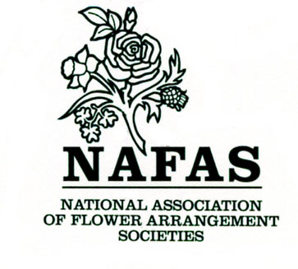
RISK ASSESSMENT
Hazard

Look for hazards which you could reasonably expect to result in significant harm - use the following examples as a guide:

- Working from heights
- Manual handling
- Noise
- Blocking fire exits
- Stacking chairs/tables too high
- Trailing electrical cables/extensions
- Water on the floor

Who might be at risk?

- Committee members
- Club members
- Members of the public/visitors
- Demonstrators/speakers

Is more needed to control the risk?

For the hazards listed, ensure precautions taken

- Represent good practice
- Reduce risk as far as reasonably practicable

Have you provided: adequate information, general instruction or training for committee i.e. fire exits, the committee role for power cut etc.

Review and Revision

Set a date for review assessment, check that the precautions for each hazard still adequately control the risk. If not indicate the action needed. Note the outcome. Keep on file.

NAFAS FUNCTIONS - HEALTH AND SAFETY

To cover yourselves from Health and Safety Claims from members:

- You need to ensure that adequate public liability insurance is in place for each and every function you undertake and what, if any, are the exclusions and limitations. The Certificate has to be on public display.
- Prior to the function, ask the venue for a copy of their health and safety audit.
- On the basis of this document carry out your own risk assessment. Your risk assessment should be on your activities not the venue.
- Risk assessment is a careful examination of your activities to highlight any areas of risk and take appropriate action to minimise the risk to a tolerable level.
- There is no distinction between voluntary and commercial organisations.
- The most important thing you need to decide is whether a hazard is significant and whether you have covered it by satisfactory precautions so that the risk is minimised.
- Steps to assessing risks:
a) Look for hazards and highlight the possible dangers
b) Evaluate the risks and existing precautions
c) If necessary implement further precautions
d) Review the assessment on a regular basis
- Do not be overcomplicated
- Do not let the words hazard and risk put you off. Hazard means anything that can cause harm. Risk is the chance, high or low that somebody will be harmed by the hazard.

NAFAS - FIRE SAFETY RISK ASSESSMENT

- Have you identified a) who could be at risk? b) who could be especially at risk?
- Have you assessed the risk to members and visitors?
- How can you make sure everyone is safe in case of fire?
- Who will know there is a fire?
- Do you have a plan to warn others?
- Who will make sure everyone gets out of the building?
- Who will call the fire service?
- Could you put out a small fire quickly and stop it spreading - familiarise yourself and the committee with any equipment and its location
- Have you discussed the plan with all the committees?
- Have you made sure everyone can fulfill their role

NAFAS RISK ASSESSMENT FORM

Risk Assessment For: | Assessment undertaken: | Assessment Review due:
Club Name | Date: | Date:
Venue address: | By:
 | Notes
Post Code:
STEP 1 | STEP 2 | STEP 3
List significant here: | List groups of people who are at risk from significant hazards you have identified | List existing controls or note where the information can be found. List risks that are not adequately controlled and the action needed.

