Structure of Meeting

After an appropriate welcome the Chairman should give out any necessary notices so that members are kept informed on Club, Area and National activities and will gain full benefit from their affiliation fee.

In introducing the Demonstrator, Speaker or Teacher it is courteous for the Chairman to include relevant facts and qualifications.

By prior arrangement a member is usually called upon to give the vote of thanks at the conclusion.

Publications/Trading

The appointed Committee member should have a display table at each meeting with essential publications, in particular The Flower Arranger (the quarterly journal of NAFAS), the order and distribution of which is their responsibility. Usually the same person sells the high quality gift items available from NAFAS Enterprises Ltd the trading subsidiary to NAFAS.

Library

This useful amenity can be launched by asking members to donate books and videos no longer needed. Further acquisitions could be made in due course.

Sales Table

A Club sales table is a popular and profitable feature, benefiting members and augmenting funds. Main trade is through specialist firms supplying a wide variety of flower arranging sundries. Prices should be kept reasonable and fair.

Further information is available from the Area Chairman or the NAFAS website regarding the following:

- The role of the Club Chairman
- The role of the Club Treasurer
- The role of the Club Secretary
- How to write minutes

See also

- Health & Safety
- Data Protection
- Child Protection Policy

NAFAS
Osborne House
12 Devonshire Square
London EC2M 4TE
Tel: 020 7247 5567
Fax: 020 7247 7232
Email: flowers@nafas.org.uk
Website: www.nafas.org.uk

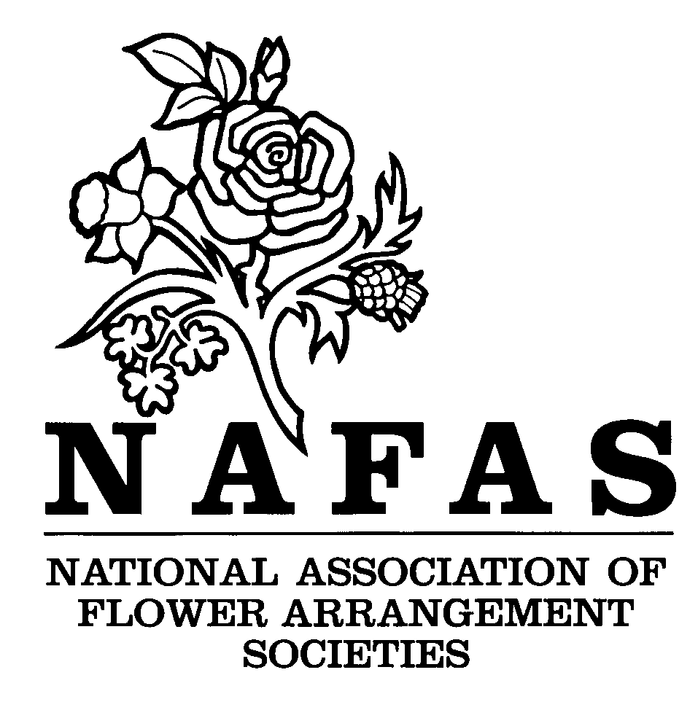

ORGANISING A FLOWER CLUB

Compiling a Programme

Running the Monthly Meeting

3 of 3
Compiling a Programme

Having set up the administration of the Club at their first meeting the Committee must consider a programme, usually delegating bookings to a Programme Secretary. It is advisable to keep meetings to a fixed day of the month.

It is important that the Club programme is drawn up one or two years in advance as many Demonstrators and Speakers are fully booked well ahead.

Demonstrations and Talks
The NAFAS Blue Form (obtainable from the Area Association) should always be used when bookings are made but most Programme Secretaries save time and unnecessary formalities by making an initial enquiry.

The cost of flowers cannot be forecast a year or more in advance, so the maximum allowance is often finally agreed just before the meeting. The other terms are binding and should be regarded as such by both parties. If the person being booked is VAT registered this should be made clear on the Blue Form.

Two or three weeks before a meeting a reminder should be sent with a map showing the location of the hall and a telephone number given for emergency use. All correspondence should be filed for reference.

Classes, Competitions and Exhibitions
Occasional practice classes at which members create exhibits usually to a theme can be introduced.

Having gained experience many members will enjoy entering a monthly competition, with a simple schedule and staging. Eventually, advanced and novice classes may become necessary. Most Demonstrators will judge and make helpful comments, but should be asked in advance. Small prizes may be awarded at the time or there could be a points system totalled at year end. A Committee member should supervise and keep records.

A Workshop covering a particular aspect of flower arranging may be organised with a suitably qualified tutor.

Consideration may be given to staging a competitive show or exhibition during the Club’s first year. Such events even on a modest scale will create public interest and attract new members. The Area Association will be pleased to give helpful advice.

If appropriate any dates of classes, competitions and exhibitions should be included in the Club programme.

Printed Programme
When the programme has been finalised the details must be carefully checked before being collated for printing, and the names and telephone numbers of Club Officers added. The year’s main National and Area events should also appear. A printed programme is given to each member on joining for the coming season and it can also serve as a membership card.

Running the Monthly Meeting

The business of the Club is conducted at Committee or general meetings and should be confined to those occasions, the main purpose of the regular members’ monthly meetings being the demonstration, talk or workshop.

Looking after the Demonstrator/Speaker/ Teacher
The general custom is to appoint a Committee member to assist the Demonstrator/Speaker/Teacher.
The duties include:
- Setting the stage
- Providing suitable tabling to display the finished exhibits
- Reserving a car space near the entrance for ease of unloading and loading
- Helping to carry flower boxes and equipment into the hall
- Serving light refreshments on arrival and any further hospitality previously agreed on the Blue Form
- Checking cloakroom facilities and showing their location
- Organising help to re-load the car after the demonstration
- Confirming that the Treasurer has settled the Demonstrator’s/Speaker’s/Teacher’s account.

Where an adjustable spot light or microphone are being used they must be checked before the meeting.

