The Constitution

At the first full Committee meeting after the formation of the Club one of the main duties should be to draw up a constitution. This is necessary to regulate the conduct of the Club and to provide for all eventualities. The following points should be considered for inclusion in the rules:

1 Name of Club

2 Objectives

3 Procedure for membership

4 Management and Policies:
- Size of the Committee
- Election of officers
- Terms and period of service for Chairman, other officers and Committee members
- Other appointments and sub Committees
- Financial year
- General meeting (i.e. when they will be held each year and the period of notice)
- Appointment of President, Vice President and/or Honorary Members (if this is agreed)
- Committee responsibilities:
Powers to co-opt
Right to act on behalf of the Club
Right to approve financial
commitments

5 Finance:
- Subscription and visitors' fees
  - Treasurer’s responsibilities
  - Bank account and signing of cheques
  - Auditing of accounts
  - Disposal of assets in the event of the Club ceasing to function

Notes: Other clauses may be considered for inclusion as local circumstances dictate.

A copy of the Constitution should be given to each member on joining.

The National Association of Flower Arrangement Societies does not undertake to issue a standard form of constitution.

NAFAS
Osborne House
12 Devonshire Square
London EC2M 4TE

Tel: 020 7247 5567
Fax: 020 7247 7232
Email: flowers@nafas.org.uk
Website: www.nafas.org.uk

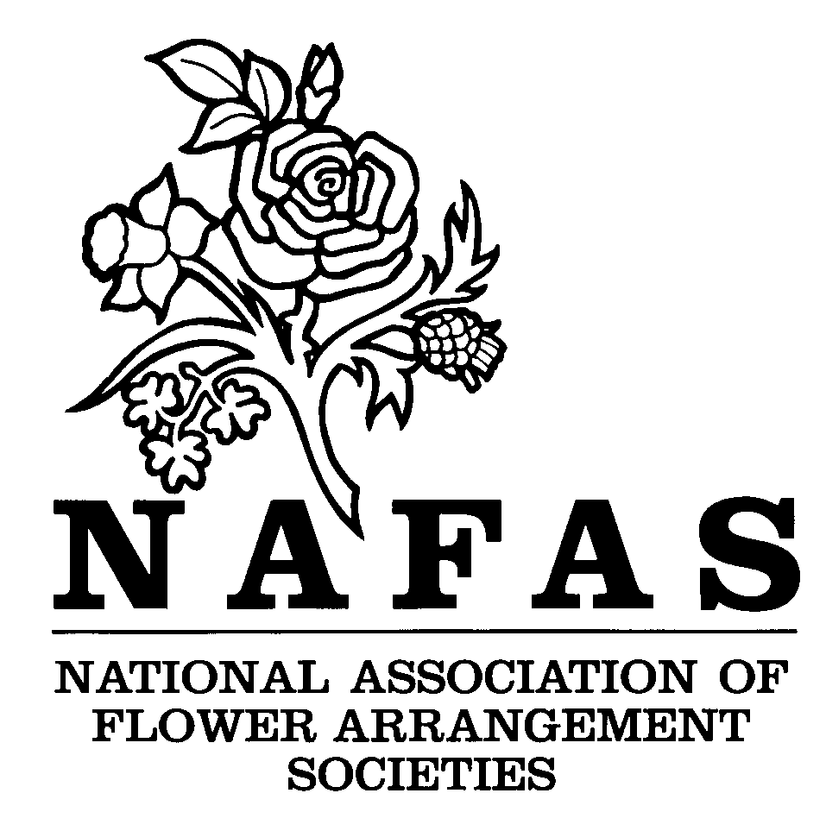

ORGANISING A FLOWER CLUB

How to Form a Flower Club

Advantages of Affiliation

The Constitution

1 of 3

How to form a Flower Club

Organising a new Flower Club is a responsible undertaking. It is essential to make sure that there is local need for a Club and that there are enough potential members to guarantee that it will be financially viable.

It is recommended that a representative of the relevant Area of NAFAS be contacted at this stage who will be able to provide informed advice which will prove invaluable.

For information contact:

NAFAS Headquarters on 020 7247 5567

or

via email at flowers@nafas.org.uk

Advantages of Affiliation

It is strongly advised that the new Club should affiliate to the Area Association and thereby to NAFAS, the advantages of which are many.

1 Access to essential publications:
a The National List of Judges, Demonstrators, Speakers and Teachers
b The Area List of Judges, Demonstrators, Speakers and Teachers
c The Flower Arranger (the quarterly journal of NAFAS)
d Competitions Manual
e A wide range of instruction leaflets
f Several books on specialist subjects including the NAFAS Course
g Application forms for booking demonstrators, judges and speakers
h Access to NAFAS Enterprises Ltd, the trading subsidiary of NAFAS, which sells high quality stationary and gift items specially produced for the Association
i A mail order book service

2 The Area Association organises day schools; demonstrators’, judges’ and speakers’ courses and tests; exhibitions and competitions; social events and regular meetings of Club representatives which encourage an inter-change of ideas.

3 The Councils of all Area Associations are composed of representatives from their affiliated Clubs, where views on policies which affect them can be discussed.

4 NAFAS organises annually a National Show open to the public and a residential Assembly for its affiliates. Study courses, social occasions and a Travel Club are open to members. Good communications are of prime concern and the National Office keeps the Areas in touch by circulating notices and information. NAFAS is a member of the World Association of Flower Arrangers and participates in international events.

5 NAFAS recommends that all Clubs are insured through a reputable insurance company. Full details are available from Area Treasurers.

