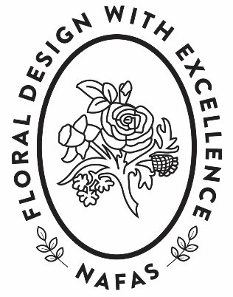
RESCUE PLAN FOR AILING CLUBS
Does Your Club have a problem with falling
membership?
Do you have difficulty finding a club chairman
and/or officers?
Are you thinking your club might have to close?

NAFAS is a wonderful organisation where fun and friendship can be experienced through floral art and design. We want to pass on this enjoyment to the next generation so this leaflet has been prepared to help all flower clubs address problems they are currently experiencing.

Before things get serious ask for help and advice from your Area
See if you can turn things around by changing some of what you do...

Try changing
- The day you meet
- The time you meet – try 11am start for young Mums
- The day of the month you meet
Check your meeting doesn’t clash with those of nearby clubs

If you have a large venue then try
- Something smaller
- A different location – out of town with better parking, in a pub, barn, garden centre, community lounge, school, sheltered housing, leisure centre, golf club
- Offer more refreshments – a cream tea or ploughman’s lunch, for example, as part of the meeting (with price stated) and advertise
- Create a different kind of flower club – much less formal or more
‘hands on’
Advertise in/on
- Local papers especially in free ones
- Church/parish news
- Leaflets about the club delivered to the local area or which can be given out at a local Flower Show – perhaps include a free entry ticket to one club meeting or an Open meeting
- Social Media – prepare a club web page, use free sites for local community groups, tweet on Twitter, use Facebook to show what keen members are up to
- Local radio
- Local table top sales – do posies or baskets
- Gatherings of local societies and clubs
- Exhibitions of work in the local community – have a theme or show flower arranging through the ages

At the club
- Prepare a newsletter about forthcoming events, circulate by email and have copies for those members not on line or visitors
- Ensure members know all about the NAFAS Diamond Card, how to obtain one and what members get from registering
- Give a special welcome to any visitors
- Give new members a complimentary copy of The Flower Arranger and an Area magazine
- Help new members to integrate within the club – make them feel ‘at home’. Have a special person or Membership Host to ensure that they have someone to sit with, ask how they are and spend a little time with them answering questions or explaining how the club works
- Create a really friendly atmosphere for all so that members look forward to attending
- Try a ‘bring a friend’ meeting
- Personally invite members onto the Committee; explain how it the Committee works making any job not sound too onerous
- Create an ‘A-Team’ of willing helpers who can step in when jobs need doing
- Consider job sharing – have Committee members who take it in turn to do notices or organise meetings
- Run small basic workshops for a change where all components are supplied – refer to the NAFAS Illustrated Booklets of Designs for Flower Arranging 1 and 2. Qualified Teacher/experienced members might consider advertising outside the club and find out about the new NAFAS Recruitment Initiative
- Run ‘how-to’ sessions on leaf manipulation and other contemporary topics for members, with reference to the NAFAS Handbooks
- Incorporate fun craft activities into the club programme, perhaps on another day

Workshops and craft sessions can conveniently be run in small venues or even members’ homes. Craft is very ‘on trend’ at the moment and through such gatherings of like-minded people, members get to know one another socially. A cup of tea or coffee with cake/homemade items helps everything go down a treat as well as providing the opportunity to learn new skills related to flower arranging. The emphasis should be on Fun and Friendship at all times.

If you have had a successful recruitment drive let your Area and National Officers know how you did it
Your idea could be rolled out all over NAFAS so come on don’t give up
– let’s get flower arranging...

© Board of Directors January 2018

