BBandO Area of NAFAS

SETTING UP A TWITTER ACCOUNT
FOR
YOUR FLOWER CLUB
INDEX

Page No | Content
1 | Front Page
2 | Index
3 – 4 | Sign up to Twitter
4 - 5 | Choosing a User Name
6 | Profiles and Settings
6 – 7 | Add a Profile Photo
7 | Add a Header
7 – 9 | To add a Bio, Location and Website
9 - 10 | Compose a Tweet
11 – 12 | Follow some People

SIGN UP TO TWITTER
- Using an Internet browser, log on to https://twitter.com/
- Click on SIGN UP

- The following box will appear:
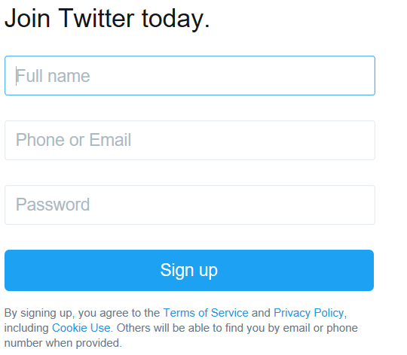

- In the FULL NAME box enter the name of your CLUB
- In the PHONE OR EMAIL box enter your phone number or email address
- In the PASSWORD box enter a password (remember to keep a note of it).
- Click on SIGN UP and the following box will appear:

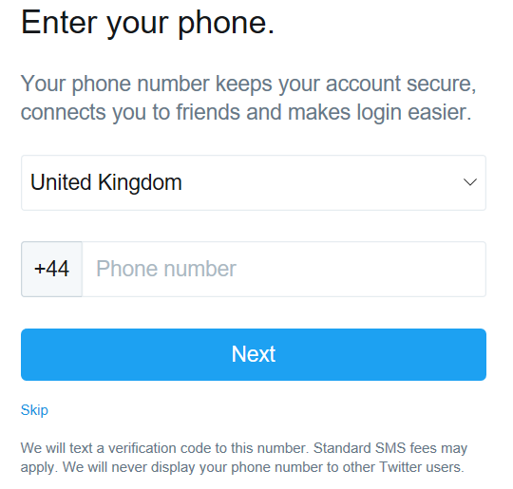

- Enter your phone number.
Note 1: It is best to use a mobile number for this.
- Click on NEXT (if you are including your telephone number)
- The following box will appear:

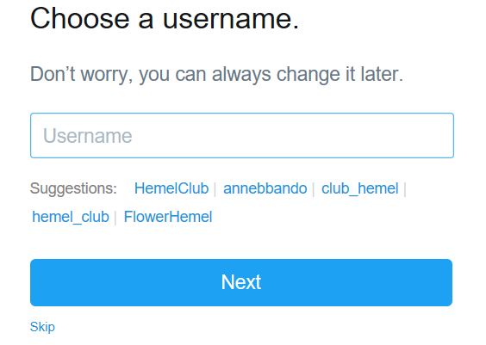

CHOOSING A USERNAME
Your USERNAME is the name you will be known as on Twitter. This is also known as your @ name.
It is recommended that you use your club name in the profile name if it is available. This could be something similar to @leyhillflowerclub or @wantageflowerclub.
Try and keep your @name as short and memorable so it does not take up too much of Twitter’s 140 character limit and also people can remember it. For instance you could shorten Chalfont and District Flower Club @chalfontflowerclub.
It is a good idea to have ‘flower’ in the Profile Name if possible. Using for instance @aylesburyfc may imply this is a football club.
Twitter will give you some suggestions but try at first the one you have chosen to see if it is available.

- Enter your chosen Username
- Click on NEXT and the following screen will appear

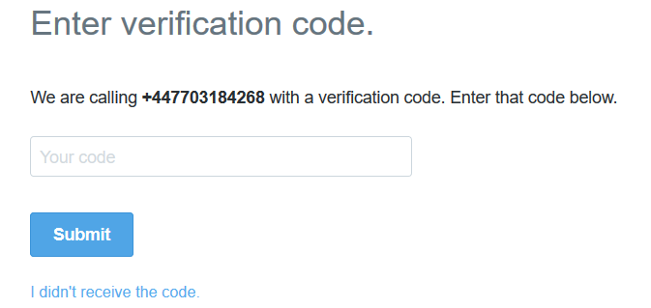

- Enter in the verification code you have received.
- Click on SUBMIT
- A similar screen will appear:

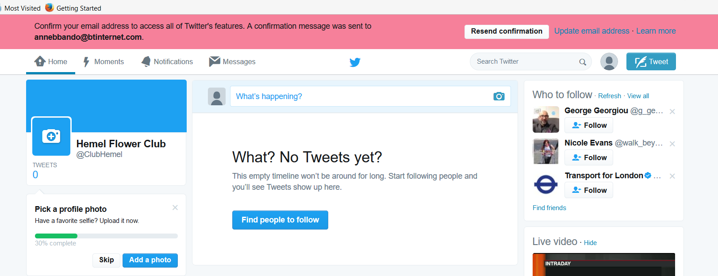

- You will need to confirm your email address so access your email account you used at the start and follow the instructions.

YOU WILL NOW BE ABLE TO ACCESS YOUR TWITTER PAGE

PROFILES AND SETTINGS
- Click on PROFILES AND SETTINGS

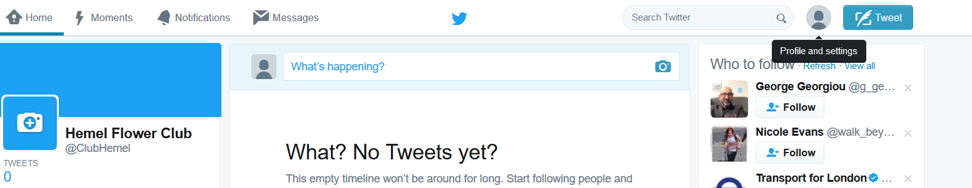

- Here you can view your profile, change your settings and privacy and log out. Click on VIEW PROFILE

ADD A PROFILE PHOTO

It is important to add a photo that is relevant to your club as your profile picture. Do not use a cartoon picture and definitely not the default egg image.
Your profile picture is displayed each time you post a tweet so you want to differentiate between your tweets and those of others.

- You page needs your club logo and a banner image. To include a profile photo, click on the camera. If you have a club logo / image, then use this here.

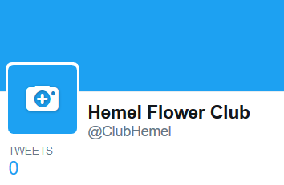
- The following box will appear and you need to click on UPLOAD PHOTO.

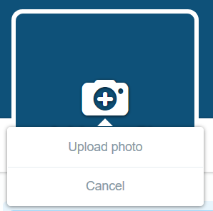

- Find your photo on your computer. For this exercise, the BBandO logo has been used. You are able to position and resize the image and when you are happy click on APPLY.

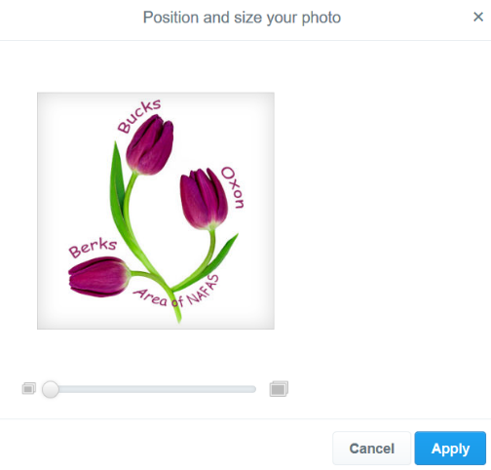

- If you are not happy with the image then click on the camera again and find a different one or adjust it.

ADD A HEADER PHOTO
This is similar to adding a profile photo.
- Click on the camera above ADD A HEADER PHOTO
- Click on UPLOAD PHOTO
- Find the photo you want to use for the header and press ENTER
- Reposition and scale the header to the size and place you want it. If you click on the image and whilst keeping your finger on the left-hand button of your mouse, you can move the image around the screen.
- When you are happy, click on APPLY.
- Click on SAVE CHANGES and you will be taken back to your Twitter Page which will include your profile photo and header photo.

TO ADD A BIO, LOCATION AND WEBSITE
- Click on PROFILE AND SETTINGS (top left to the left of the Tweet Button)
- Click on VIEW PROFILE
- Click on EDIT PROFILE
- In the box shown below, enter your location, website address (if you have one) and your bio.
Note 1: BIO - You have 160 characters to explain to everyone what you do and why you do it. Use this to make a connection between you and others.
Note 2: WEBSITE ADDRESS - If you club has a website address, there is a space to add this on your profile. Use this even if you don’t have a website. Instead, you could link it to your Facebook page so that people can find out more about your club.
Note 3: LOCATION – enter in the town name where your club is based e.g. Amersham, Bucks. It will not allow you to enter the full address.

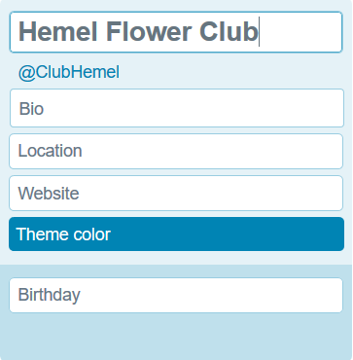

- You are able to change the theme colour if you wish. Click on THEME COLOUR and select the colour you would prefer.
- Click on THEME COLOUR again and it will take you back. For this exercise the theme colour has been changed to purple.
- If you want to add the date your club started (if it is known) then click on BIRTHDAY and enter in the month, day and year.
Note: If you do not know this then leave it blank as you are unable to just add in for instance the year.
- Your screen will look similar to the one below:

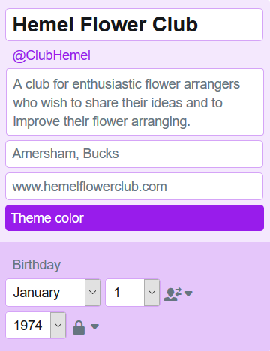

- Click on SAVE CHANGES and you will see that your page now shows the information you have just entered:

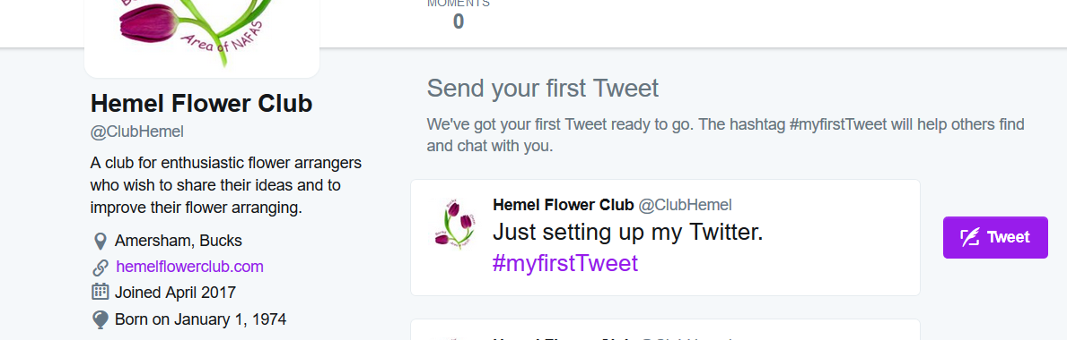

COMPOSE A NEW TWEET

- Click on the TWEET button

- The following box will appear:
- In the WHAT’S HAPPENING? Box type in your Tweet. The number alongside the Tweet button will show you how many characters you have left. For this exercise, there was 140 characters to start with.

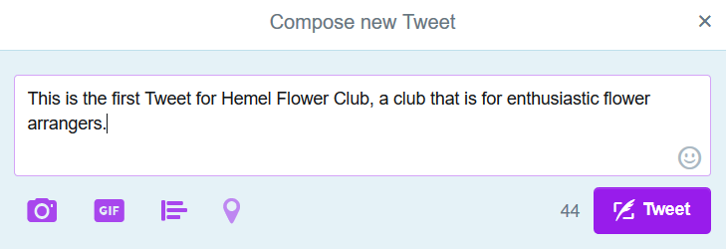

Note: You will see that there are 44 characters left to use for this Tweet. If you have typed too many characters it will show as a minus (-) and you will be unable to click on the Tweet button.
- Click on TWEET

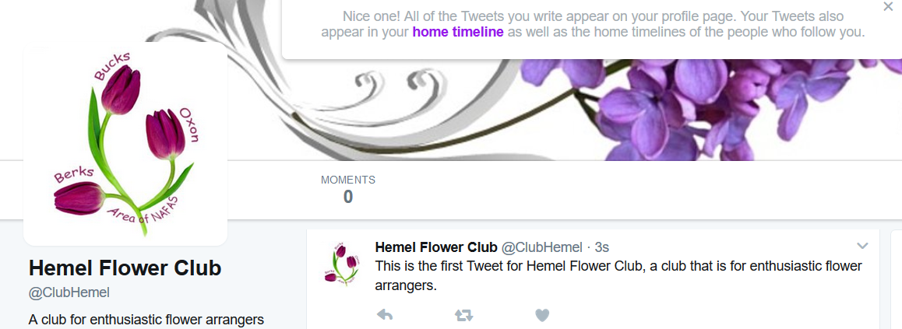

YOU HAVE NOW POSTED YOUR FIRST TWEET

FOLLOW SOME PEOPLE
You can follow whoever you want but more importantly you want to follow profiles that are linked with Floral Arranging / Flower Clubs etc. It is best not to follow too many profiles to start with as you can become overwelmed.
A good place to start is to look at who is following profiles with the same kind of clubs / interests.
For this exercise, you will learn to follow NAFAS (National Association of Flower Arrangement Societies.
- In the SEARCH TWITTER box, enter NAFAS FLOWERS and the following will appear:

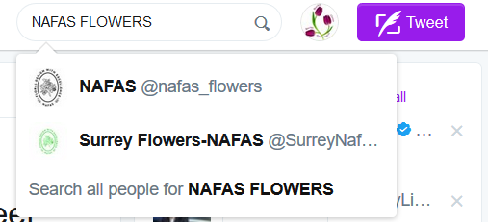

- Click on NAFAS and this will take you to the NAFAS Twitter Page.
- Take this opportunity to see the type of Tweets they have written to get ideas for your Twitter page.
- Now click on FOLLOW

- This will now change to FOLLOWING
- Go back to your Twitter page by clicking on PROFILE AND SETTINGS

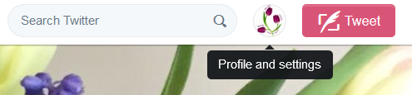

- Click on VIEW PROFILE and this will take you back to your page. You will see that you now show as Following one page

- To find more people to follow if you click on VIEW ALL in the WHO TO FOLLOW box and it will show people linked to Flower Arranging.

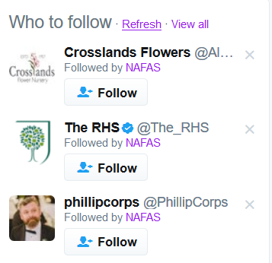
- Click on the page you would like to follow and this will then take you to your chosen persons page e.g. The RHS.
- Click on the FOLLOW button.
Note: Remember, don’t follow too many to start with and be selective.

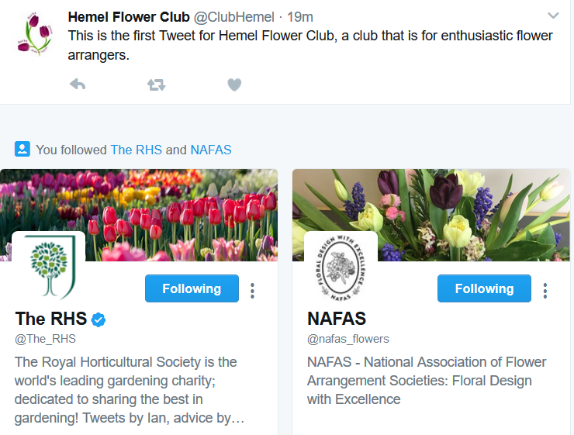

It is important to Tweet regularly so
GET TWEETING

