Guidelines for Programme Secretaries

A successful club is one where members are happy and pleased with the programme. Your role is a very rewarding one and important in the life of the club.

In the first instance refer to the code of practice regarding demonstrations.

Preparation of a Club Programme

- At least one year ahead discuss with the committee the budget for the year in question.

- Check club meeting dates for that year. Some may have to be altered for seasonal reasons e.g. Easter.

- Consult Area and National Lists for demonstrators and speakers depending on the type of meeting. The National List is available through Trading Officers at Area Level or through the Distribution Officer at NAFAS HQ; a new edition comes out every 2 years. Area Lists are available for a small fee from each NAFAS Area (details in the National List). Please note that black dots indicate those who have attended Refresher Days.

- National Demonstrators should be booked at least 2 years ahead of the meeting.

- When choosing demonstrators or speakers take into account travelling distance during wintertime. Book January and February first – these need to be filled with a person living fairly close in case of inclement weather.

- Telephone the person to see if they are available and ask their fee.

- Book the Christmas demonstrator at least 2 years in advance, particularly if it is an open meeting and a National Demonstrator is wanted.

Fees and Flower Allowance

- Fees vary and if in doubt consult the club committee before confirming the booking. Note mileage costs.*

- It may be necessary to negotiate. If the club allowance for flowers is less than the demonstrator considers necessary it may be that they can be asked for one less arrangement.

The NAFAS Blue Form

- The Blue Form is used to book only NAFAS demonstrators and speakers. Complete part A with the details agreed on the telephone and send all three parts, together with a stamped addressed envelope, to the person being booked.

At this stage a map and layout of the stage should be included

The person will retain part A, complete part B and return parts B and C to you. After checking all details on both parts of the form are correct keep part B and sent part C to the demonstrator or speaker.

NO BOOKING IS FINALISED UNTIL THIS PROCESS IS COMPLETED

- Three weeks prior to the meeting send a reminder, directions (including the postcode of the venue) and a contact mobile telephone number. Demonstrators and speakers should acknowledge receipt of this letter. If the flower allowance has not been agreed, state the amount. If, due to fluctuations in the market, an increase is requested, this should be agreed by telephone.

- Liaise with the club hostess about the requirements for the visitor e.g. refreshments, time of arrival etc.

- Ensure someone can assist by carrying items both before and after the meeting. This is important where access is difficult.

Cancellations/Contingency

- On some occasions mitigating circumstances may lead to a cancellation by the demonstrator or speaker; however they should endeavour to find an acceptable replacement if under 6 months to the event.

- Have a contingency plan to entertain members should the demonstrator or speaker be delayed or not arrive at all.

It is useful to learn from other clubs of demonstrators and speakers they have enjoyed. Keep a note of when a person has been booked so those visits are spread over a period of time.

* Be aware that travel costs can be shared when a demonstrator or speaker is booked as part of a short tour. Ask your Area Demonstrators’ Representative, or your Area JDS&E Committee, for advice and information.

National Association of Flower Arrangement Societies
Osborne House
12 Devonshire Square
London

Tel: 020 7247 5567
Fax: 020 7247 7232
email: flowers@nafas.org.uk

NAFAS Website
www.nafas.org.uk

Registered charity number
1101348

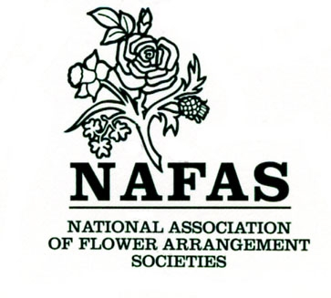

GUIDELINES
FOR
PROGRAMME
SECRETARIES
BOOKING DEMONSTRATORS
AND
SPEAKERS

Please pass this leaflet on
to your successor

